Our Pillars of MFL-Spanish
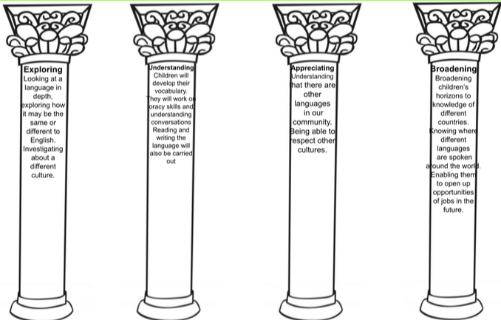
Our aim is to develop the confidence and competence of each child in the foreign language they are learning. Our goal is for them to be passionate, curious and confident about their own foreign language learning abilities when they finish the primary school phase of their education.
We will help them develop and demonstrate substantial progress in the 5 key language skills necessary for learning Spanish:
- Speaking
- Listening
- Reading
- Writing
- Grammar
We aim to ensure that pupils of all abilities develop solid foundations in these key language learning skills - properly preparing them for the next stage of their language-learning journey. These skills will develop children’s ability to understand what they hear and read and enable them to express themselves in speech and writing. We will extend their knowledge of how language works and explore the similarities and differences between the foreign language they are learning and English. We will also help strengthen their sense of identity through learning about culture in other countries and comparing it with their own.
Our approach to language teaching and learning is in line with the recommendations of the National Curriculum and the requirements outlined in the Department for Education Languages Programme of Study for Key Stage 2.
The National Curriculum for languages aims to ensure that all pupils:
- Understand and respond to spoken and written language from a variety of authentic sources
- Speak with increasing confidence, fluency and spontaneity, finding ways of communicating what they want to say, including through discussion and asking questions, and continually improving the accuracy of their pronunciation and intonation
- Can write at varying length, for different purposes and audiences, using the variety of grammatical structures that they have learnt
- Discover and develop an appreciation of a range of authentic writing in the language studied.
By the end of key stage 2, pupils should be able to:
- Listen attentively to spoken language and show understanding by joining in and responding.
- Explore the patterns and sounds of language through songs and rhymes and link the spelling, sound and meaning of words.
- Engage in conversations; ask and answer questions; express opinions and respond to those of others; seek clarification and help.
- Speak in sentences, using familiar vocabulary, phrases and basic language structures.
- Develop accurate pronunciation and intonation so that others understand when they are reading aloud or using familiar words and phrases.
- Present ideas and information orally to a range of audiences.
- Read carefully and show understanding of words, phrases and simple writing.
- Appreciate stories, songs, poems and rhymes in the language.
- Broaden their vocabulary and develop their ability to understand new words that are introduced into familiar written material, including through using a dictionary.
- Write phrases from memory, and adapt these to create new sentences, to express ideas clearly.
- Describe people, places, things and actions orally and in writing.
- Understand basic grammar appropriate to the language being studied, including (where relevant): feminine, masculine and neuter forms and the conjugation of high-frequency verbs; key features and patterns of the language; how to apply these, for instance, to build sentences; and how these differ from or are similar to English.
Teachers plan their lessons using the Language Angels scheme of work and can supplement this with their own ideas, experience, and those of their colleagues.
Each lesson will focus on a combination of the 5 key language-learning skills (speaking, listening, reading, writing and grammar).
Long Term Plan
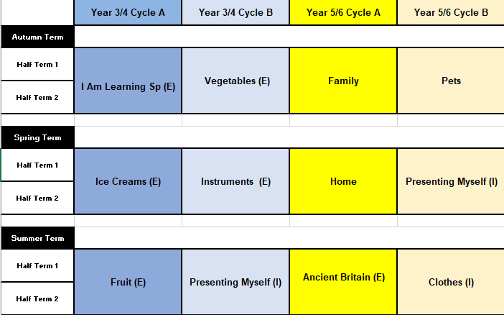
Our long-term plan has been devised alongside the Language Angels team
EYFS & KS1
We ask that children in EYFS and KS1 become exposed to the beginnings of the language by using key phrases to answer the register in for example: good morning/good afternoon/ hello and practicing numbers from 1-10. This then allows the children to have had the exposure of the language before they enter Key Stage 2.

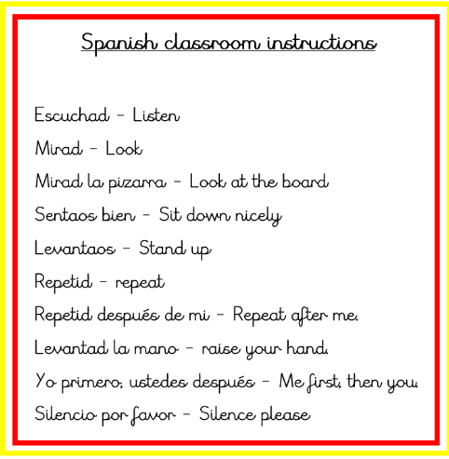
Classroom Instructions
Here are some key Spanish phrases to be used in Key Stage 2 classrooms when delivering Spanish lessons- you may wish to bring these into other sessions of learning too in order to consolidate. These could be printed off to use as a prompt for the class teacher.
Medium Term Plans
Each unit has a medium term plan to go alongside it. Learning objectives for each lesson are displayed and to be used. This contains the assessment for the whole unit too. On your planning days, populate the task ideas. Please think about the evidence, you will put in your class book and if any display is needed for the lesson.
Ensure there is a mix of Speaking, Listening, Writing, Reading and Grammar across the unit.
A Guide to using Language Angels
Step 1
Login to Language Angels: http://www.languageangels.com/schools/
Step 2:

Select whether you are teaching an Early Language or Intermediate unit- an E or I indicate this on the Long Term Plan
Step 3
Select your unit- you will be able to select the lesson you are teaching.
Within lesson 1, you will find Class Display Materials that can be used to enhance the unit and add to your classroom.

Step 4

- You will need to consider resources, space and time.
- You will need to adapt the plan in relation to your class’s needs, planning differentiation where appropriate.
- There are PowerPoints and songs available on each lesson for you to select.

Other useful resources:
https://www.lightbulblanguages.co.uk/resources-spanish.htm

