PSHE KNOWLEDGE ORGANISER Year 5
Growing and Changing
Overview of lesson objectives |  | Books and websites to support
In this unit, you will learn:  Lesson 1 :  - To distinguish between good and not so good feelings - using appropriate vocabulary.  - Explain strategies to build resilience  Lesson 2:  - To identify some products that may be needed during puberty and why  - Discuss the differences in how male and female bodies change.  Lesson 3:  - To know the correct words for the external sexual organs  - Discuss some of the myths associated with puberty.  Lesson 4:  - To recognise how our body feels when we’re relaxed  - Explain some of the ways our body feels when it is nervous or sad  Lesson 5:  - To recognise that others are often stereotyped unfairly.  - Suggest examples of how bullying behaviours can be stopped |  | 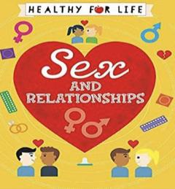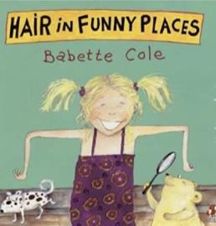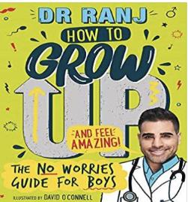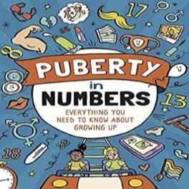  https://childrenshealthsurrey.nhs.uk/services/advice-talking-your-children-years-5-6-about-puberty  https://www.bbc.co.uk/bitesize/guides/znxnscw/revision/6
Content of Lessons
Lesson 1 - How are you feeling? | Lesson 3 - How do our bodies develop?
- We will discuss different emotions and how to explain that emotion.  - We will develop strategies to deal with our feelings and think about how to cope with them. | - We will label the diagrams to the left to share the correct scientific vocabulary with the children.  - We will then discuss different emotions that the children may experience during puberty and complete a true or false activity.  - During this lesson we will share age appropriate ‘colloquial’ terms for the genitalia that the children know in order to ensure that they know these are not the scientific terms. |  | 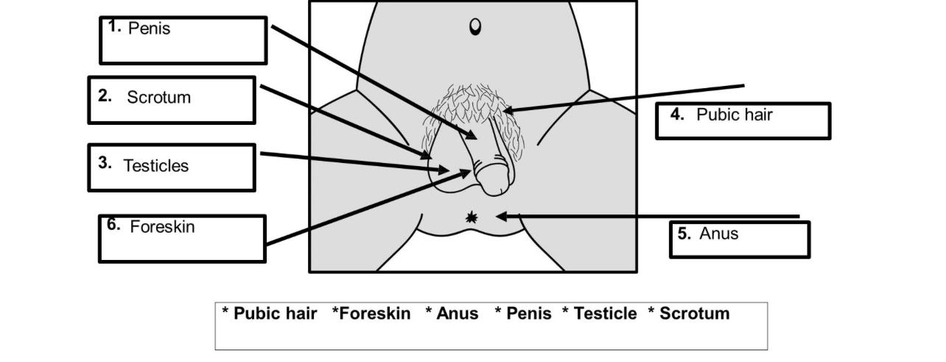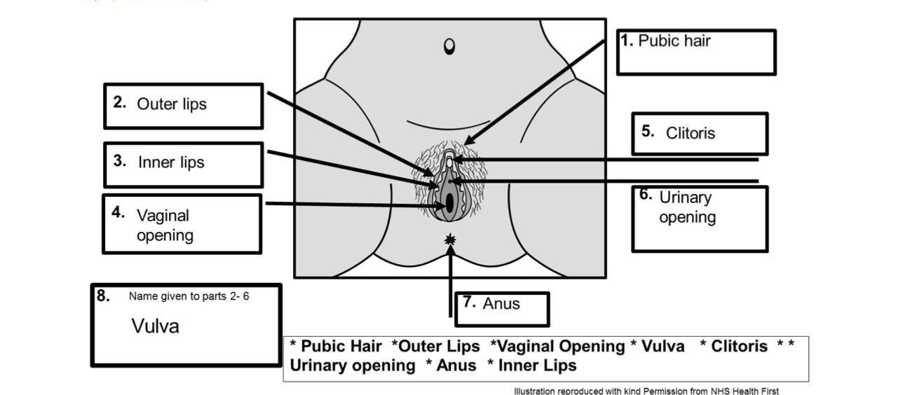
Lesson 2 - What might I need in puberty? | Lesson 4 - How does it feel to be a teenager? |  | Lesson 5 - What is prejudice?
- We will discuss what puberty is and highlight that our bodies change as we grow up.  - We will look at a variety of products such as deodorant, shower gel, spot cream, and period products and discuss why we might use them.  - We will discuss the ways a female body changes including breasts developing, vagina beginning to self clean, periods beginning, and body hair growing.  - We will discuss the ways a male body changes including body hair, penis growth, semen beginning to be produced, and erections and wet dreams. | - We will discuss conflicts that may arise during puberty due to heightened emotions and how to deal with these.  - We will develop strategies for dealing with difficult situations. |  | - We will discuss different areas of diversity that people may have a problem with such as gender identify, sexual orientation, and gender expression.  - We will discuss stereotypes, what these mean, and how to deal with people who use them against us.
KEY VOCAB
Tampons Sanitary pads Puberty Hormones Vagina Penis Menstrual cycle Pubic hair Foreskin Anus Testicle Scrotum Labia Vulva Clitoris

Vocabulary and definitions
cervix | The plug at the end of the vaginal passage and the start (neck) of the uterus
Fallopian tubes | 2 tubes which the ova (eggs) travel along to reach the uterus (womb).
genitals | Name given to all the external sexual organs
Gender expression | How a person shows their gender by the way they act, behave, dres etc.
Gender identity | How a person feels about themselves in their head. Whether they feel they are a boy or girl or neither
Hair | Body hair appears around the genitals first (pubic hair) and then grows under the  arms and on the legs. Young men also grow hair on their chest and face.
IVF | Where specialist doctors fertilise the egg of the woman with the sperm of the man, but outside of the body. The fertilised egg creates an embryo which is then put back inside the woman so she becomes pregnant and grows the baby inside her uterus/womb.
Labia | Includes both the smaller lips/folds of skin that surround the entrance to the vagina and urethra (wee hole), and the outer lips/folds of skin that surround the inner lips.
menstruation | Another word for periods. A loss of blood (usually monthly) as the unused ovum (egg) comes out of the vaginal opening along with the lining of the uterus.
ovary | where the ova (eggs) are kept. There are usually two.
puberty | Emotional and physical changes that happen in early adolescence, as the body begins to mature sexually and develop.
penis | This is the shaft shaped reproductive organ that hangs outside the male body. An organ that can help transport urine (wee) and sperm away from the body.
Sexual reproduction | Occurs when a male sex cell (sperm) and the female sex cell (egg) join. This fusion of sex cells is called fertilisation. Sexual reproduction allows some of the genetic information from each parent to mix, producing offspring that resemble their parents, but are not identical to them. In this way, sexual reproduction leads to variety in the offspring.
scrotum | Sack or pouch which hold testicles. During puberty the scrotum becomes baggy, helping the testicles to hang away from the body. This helps to keep the temperature down, which allows sperm to be produced.
testicles | Also known as ‘balls’, these are held in the scrotum (sack/ball bag) found below the penis, which produce millions of sperm every day.
urethra | The tube which runs from the bladder to the outside of the body, either through  the penis or to an opening above the entrance to the vagina. It also carries sperm to the penis.
uterus | A fertilised egg (one that has joined a sperm) embeds itself into the lining of the uterus and grows into a baby. If this doesn’t happen the lining of the uterus comes away as part of a period and renews itself for the next month.
vagina | The opening of the reproductive part of the girl’s body (the passage which leads to the womb).
vulva | Vulva refers to the external parts of the girl’s genitals which you can see.

