PSHE KNOWLEDGE ORGANISER Year 2
Growing and Changing
Overview of lesson objectives |  | Books and websites to support at home
In this unit, you will learn:  Lesson 1 :  - To show ways we can be helpful  - Demonstrate positive feedback  Lesson 2:  - To explore feelings of losing and reuniting with someone.  - Recognise my feelings  Lesson 3:  - To identify stages of growth  - Describe some of the things people can do at these stages.  Lesson 4:  - To identify which parts of the human body are private.  - Explain that a person’s genitals help them to make babies when they grow up.  Lesson 5:  - To explain what privacy means  - Explain that you should not touch others belongings without their permission |  | 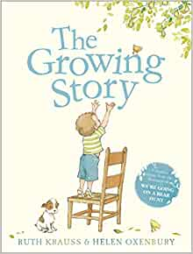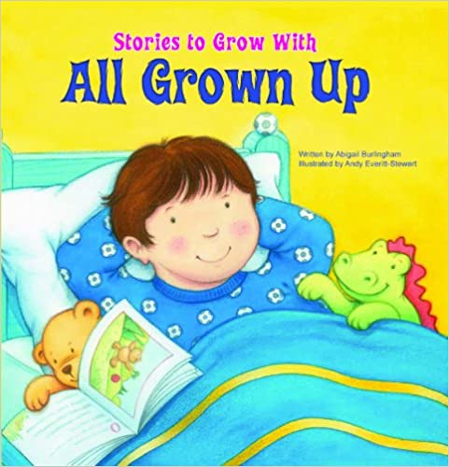  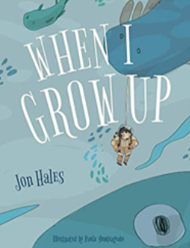
Content of Lessons
Lesson 1 | Lesson 2 |  | Lesson 3
-We will be looking at how can we be helpful..  -We will be looking at ways we can be helpful and demonstrating positive feedback. | -We will be discussing how we feel when we say goodbye.  - We will be exploring feelings of losing and reuniting with someone.  -We will be recognising our feelings. |  | -We will be looking at how much we have grown.  -We will be identifying stages of growth.  -We will be describing some of the things people can do at these stages.
Lesson 4 |  |  | Lesson 5
-We will be looking at what our bodies look like.  -We will be identifying which parts of the human body are private.  -We will be explaining that a person's genitals help them to make babies when they grow up. | 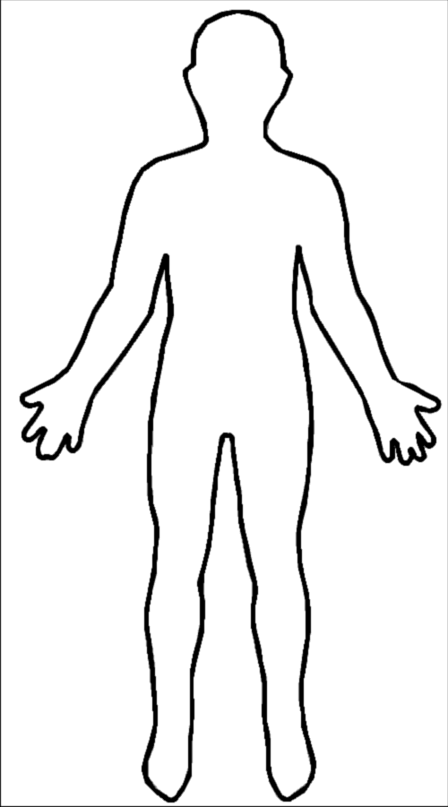  Penis  vulva  Testicle  Nipples |  | -We will be looking at what privacy means.  -We will explain what privacy means.  -We will explain that you should not touch others belongings without their permission.
KEY VOCAB
penis vulva testicles nipples

Vocabulary and definitions
penis | This is the reproductive organ that hangs outside the male body. An organ that can help transport urine (wee)
testicles | Also known as ‘balls’, these are held in the scrotum (sack/ball bag) found below the penis
vulva | Vulva refers to the external parts of the girl’s genitals which you can see.
nipples | Males and females have nipples. Females use their nipples for feeding their babies.

