PSHE KNOWLEDGE ORGANISER Year 3
Growing and Changing
Overview of lesson objectives |  | Books and websites to support at home
In this unit, you will learn:  Lesson 1 :  - To identify different relationships  - Recognise the characteristics of a healthy relationship  Lesson 2:  - To know who to ask for help if a secret makes me feel uncomfortable  - Recognise how secrets and surprises might make you feel  Lesson 3:  - To understand what body space is.  - identify what is inappropriate or appropriate  Lesson 4:  - Recognise that babies come from the joining of an egg and sperm  - Explain what happens when an egg doesn’t meet a sperm  Lesson 5:  - Understand that for girls, periods are a normal part of puberty  - Explain what happens when an egg doesn’t meet a sperm |  | 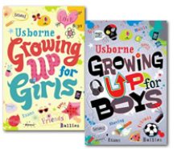  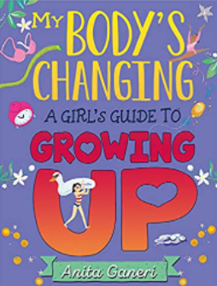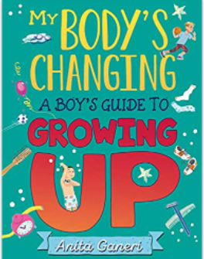
Content of Lessons
Lesson 1 | Lesson 2 |  | Lesson 3
-We will be looking at the different relationships we have : friends, family , sports coaches and at school etc.  -We will look at what sorts of things can make these relationships negative and what we can do. | -We will look at the differences between secrets and surprises. We will look at what makes a secret ‘safe’ or ‘unsafe’  -We will talk about who we could talk to if we feel unsafe and how it might make us feel. |  | -We will look at respecting other people's body space and look at reasons why others may not like the ‘invasion’ of their space.  -We will look at strategies on how to be assertive when we do not want others in our space.  -We will also explore the NSPCC underwear rules about keeping our private body parts private.
Lesson 4 |  |  | Lesson 5
-We will recap learning from Year 2 about how boys and girls have different body parts.  -We will talk about the changes that happen to the body in puberty.  -We will discuss how testicles make and store sperm and discuss how females produce eggs  -We will talk about how eggs are fertilised by a sperm to create a baby, we will discuss identical and non-identical twins.  -We will look at the diagrams on the right and discuss the parts of the reproductive organs. | 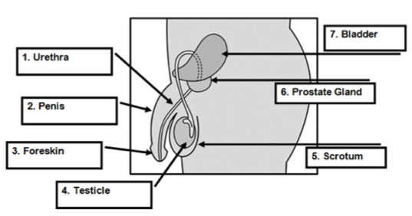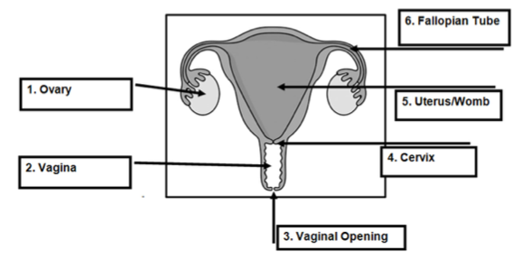 |  | -We will look at what happens if an egg is not fertilised and that the lining of the uterus passes out through the vagina.  -We will look at the process of the menstrual cycle and products that can be use whilst having a period.  -We will look at sanitary towels and tampons.
KEY VOCAB
sperm egg reproductive organs puberty ovaries testicles penis foreskin scrotum urethra fallopian tube vagina vulva cervix uterus/womb hair genitals fertilise periods sanitary towels tampons menstrual cycle

Vocabulary and definitions
cervix | The plug at the end of the vaginal passage and the start (neck) of the uterus
Fallopian tubes | 2 tubes which the ova (eggs) travel along to reach the uterus (womb).
genitals | Name given to all the external sexual organs
Hair | Body hair appears around the genitals first (pubic hair) and then grows under the  arms and on the legs. Young men also grow hair on their chest and face.
IVF | Where specialist doctors fertilise the egg of the woman with the sperm of the man, but outside of the body. The fertilised egg creates an embryo which is then put back inside the woman so she becomes pregnant and grows the baby inside her uterus/womb.
menstruation | Another word for periods. A loss of blood (usually monthly) as the unused ovum (egg) comes out of the vaginal opening along with the lining of the uterus.
ovary | where the ova (eggs) are kept. There are usually two.
puberty | Emotional and physical changes that happen in early adolescence, as the body begins to mature sexually and develop.
penis | This is the shaft shaped reproductive organ that hangs outside the male body. An organ that can help transport urine (wee) and sperm away from the body.
Sexual reproduction | Occurs when a male sex cell (sperm) and the female sex cell (egg) join. This fusion of sex cells is called fertilisation. Sexual reproduction allows some of the genetic information from each parent to mix, producing offspring that resemble their parents, but are not identical to them. In this way, sexual reproduction leads to variety in the offspring.
scrotum | Sack or pouch which hold testicles. During puberty the scrotum becomes baggy, helping the testicles to hang away from the body. This helps to keep the temperature down, which allows sperm to be produced.
testicles | Also known as ‘balls’, these are held in the scrotum (sack/ball bag) found below the penis, which produce millions of sperm every day.
urethra | The tube which runs from the bladder to the outside of the body, either through  the penis or to an opening above the entrance to the vagina. It also carries sperm to the penis.
uterus | A fertilised egg (one that has joined a sperm) embeds itself into the lining of the uterus and grows into a baby. If this doesn’t happen the lining of the uterus comes away as part of a period and renews itself for the next month.
vagina | The opening of the reproductive part of the girl’s body (the passage which leads to the womb).
vulva | Vulva refers to the external parts of the girl’s genitals which you can see.

