Westwood Primary School
and
Grove Primary School

PSHE Handbook
2022-23

I

Aim
The aim of this PSHE handbook is to equip teachers with the necessary resources, ideas and freedom to teach quality PSHE lessons based on the needs of the children and to provide an overview of where PSHE fits into our curriculum design. It also provides information about how PSHE is taught both discretely in lessons and across a range of platforms such as assemblies across the school year and the school year groups.
National curriculum
The document below summarises the Relationships Education, relationships and Sex Education and Health Education Curriculum for primary school children.
It is important to note however, that the statutory guidance sets out what must be covered, not everything that we feel should be covered in our schools. Our PSHE education curriculum covers, and goes beyond, this statutory guidance e.g. economic well being.
Relationships Education
Families and people who care for me | Pupils should know:  • that families are important for children growing up because they can give love, security and stability.  • the characteristics of healthy family life, commitment to each other, including in times of difficulty, protection and care for children and other family members, the importance of spending time together and sharing each other’s lives.  • that others’ families, either in school or in the wider world, sometimes look different from their family, but that they should respect those differences and know that other children’s families are also characterised by love and care.  • that stable, caring relationships, which may be of different types, are at the heart of happy families, and are important for children’s security as they grow up.  • that marriage represents a formal and legally recognised commitment of two people to each other which is intended to be lifelong.  • how to recognise if family relationships are making them feel unhappy or unsafe, and how to seek help or advice from others if needed.
Caring friendships | Pupils should know:  • how important friendships are in making us feel happy and secure, and how people choose and make friends.  • the characteristics of friendships, including mutual respect, truthfulness, trustworthiness, loyalty, kindness, generosity, trust, sharing interests and experiences and support with problems and difficulties.  • that healthy friendships are positive and welcoming towards others, and do not make others feel lonely or excluded.  • that most friendships have ups and downs, and that these can often be worked through so that the friendship is repaired or even strengthened, and that resorting to violence is never right.  • how to recognise who to trust and who not to trust, how to judge when a friendship is making them feel unhappy or uncomfortable, managing conflict, how to manage these situations and how to seek help or advice from others, if needed.
Respectful relationships | Pupils should know:  • the importance of respecting others, even when they are very different from them (for example, physically, in character, personality or backgrounds), or make different choices or have different preferences or beliefs.  • practical steps they can take in a range of different contexts to improve or support respectful relationships.  • the conventions of courtesy and manners.  • the importance of self-respect and how this links to their own happiness.  • that in school and in wider society they can expect to be treated with respect by others, and that in turn they should show due respect to others, including those in positions of authority.  about different types of bullying (including cyberbullying), the impact of bullying, responsibilities of bystanders (primarily reporting bullying to an adult) and how to get help.  • what a stereotype is, and how stereotypes can be unfair, negative or destructive.  • the importance of permission-seeking and giving in relationships with friends, peers and adults.
Online relationships | Pupils should know:  • that people sometimes behave differently online, including by pretending to be someone they are not.  • that the same principles apply to online relationships as to face-to-face relationships, including the importance of respect for others online including when we are anonymous.  • the rules and principles for keeping safe online, how to recognise risks, harmful content and contact, and how to report them.  • how to critically consider their online friendships and sources of information including awareness of the risks associated with people they have never met.  • how information and data is shared and used online
Being safe | Pupils should know:  • what sorts of boundaries are appropriate in friendships with peers and others (including in a digital context).  • about the concept of privacy and the implications of it for both children and adults; including that it is not always right to keep secrets if they relate to being safe.  • that each person’s body belongs to them, and the differences between appropriate and inappropriate or unsafe physical, and other, contact.  • how to respond safely and appropriately to adults they may encounter (in all contexts, including online) whom they do not know.  • how to recognise and report feelings of being unsafe or feeling bad about any adult.  • how to ask for advice or help for themselves or others, and to keep trying until they are heard.  • how to report concerns or abuse, and the vocabulary and confidence needed to do so.  • where to get advice e.g. family, school and/or other sources.
Physical Health and Mental Well-being:

Mental wellbeing | Pupils should know:  • that mental wellbeing is a normal part of daily life, in the same way as physical health.  • that there is a normal range of emotions (e.g. happiness, sadness, anger, fear, surprise, nervousness) and scale of emotions that all humans experience in relation to different experiences and situations.  • how to recognise and talk about their emotions, including having a varied vocabulary of words to use when talking about their own and others’ feelings.  • how to judge whether what they are feeling and how they are behaving is appropriate and proportionate.  • the benefits of physical exercise, time outdoors, community participation, voluntary and service-based activity on mental wellbeing and happiness.  • simple self-care techniques, including the importance of rest, time spent with friends and family and the benefits of hobbies and interests.  • isolation and loneliness can affect children and that it is very important for children to discuss their feelings with an adult and seek support.  • that bullying (including cyberbullying) has a negative and often lasting impact on mental wellbeing.  • where and how to seek support (including recognising the triggers for seeking support), including whom in school they should speak to if they are worried about their own or someone else’s mental wellbeing or ability to control their emotions (including issues arising online).  • it is common for people to experience mental ill health. For many people who do, the problems can be resolved if the right support is made available, especially if accessed early enough.
Internet safety and harms | Pupils should know:  • that for most people the internet is an integral part of life and has many benefits.  • about the benefits of rationing time spent online, the risks of excessive time spent on electronic devices and the impact of positive and negative content online on their own and others’ mental and physical wellbeing.  • how to consider the effect of their online actions on others and know how to recognise and display respectful behaviour online and the importance of keeping personal information private.  • why social media, some computer games and online gaming, for example, are age restricted.  • that the internet can also be a negative place where online abuse, trolling, bullying and harassment can take place, which can have a negative impact on mental health.  • how to be a discerning consumer of information online including understanding that information, including that from search engines, is ranked, selected and targeted.  • where and how to report concerns and get support with issues online
Physical health and fitness | Pupils should know:  • the characteristics and mental and physical benefits of an active lifestyle.  • the importance of building regular exercise into daily and weekly routines and how to achieve this; for example walking or cycling to school, a daily active mile or other forms of regular, vigorous exercise.  • the risks associated with an inactive lifestyle (including obesity).  • how and when to seek support including which adults to speak to in school if they are worried about their health.
Healthy eating | Pupils should know:  • what constitutes a healthy diet (including understanding calories and other nutritional content).  • the principles of planning and preparing a range of healthy meals.  • the characteristics of a poor diet and risks associated with unhealthy eating (including, for example, obesity and tooth decay) and other behaviours (e.g. the impact of alcohol on diet or health).
Drugs, alcohol and tobacco | Pupils should know:  • the facts about legal and illegal harmful substances and associated risks, including smoking, alcohol use and drug-taking.
Health and prevention | Pupils should know:  • how to recognise early signs of physical illness, such as weight loss, or unexplained changes to the body.  • about safe and unsafe exposure to the sun, and how to reduce the risk of sun damage, including skin cancer.  • the importance of sufficient good quality sleep for good health and that a lack of sleep can affect weight, mood and ability to learn.  • about dental health and the benefits of good oral hygiene and dental flossing, including regular check-ups at the dentist  .  • about personal hygiene and germs including bacteria, viruses, how they are spread and treated, and the importance of handwashing.  • the facts and science relating to allergies, immunisation and vaccination.
Basic first aid | Pupils should know:  • how to make a clear and efficient call to emergency services if necessary.  • concepts of basic first-aid, for example dealing with common injuries, including head injuries.
Changing adolescent body | Pupils should know:  • key facts about puberty and the changing adolescent body, particularly from age 9 through to age 11, including physical and emotional changes.  • about menstrual wellbeing including the key facts about the menstrual cycle.
Sex Education:
Sex education is not compulsory in primary schools and the content set out in the DfE’s guidance therefore focuses on Relationships Education.
Primary schools should teach about relationships and health, including puberty as set out in the National Curriculum above. The national curriculum for science also includes subject content in related areas, such as the main external body parts, the human body as it grows from birth to old age (including puberty) and reproduction in some plants and animals.It will be for primary schools to determine whether they need to cover any additional content on sex education to meet the needs of their pupils.

Where does PSHE fit within the curriculum we offer?

It is essential to note that the new DfE requirements for Relationships Education and Health Education (statutory from September 2020) don't cover all aspects of PSHE education. At Westwood and Grove, we ensure coverage of the PSHE Association's Programmes of Study so that we provide a comprehensive and effective PSHE Education curriculum

Intent
At Westwood and Grove, although students have one timetabled lesson of PSHE (Personal, Social, Health and Economic Education) each week, we believe it underpins the entire curriculum. Our PSHE curriculum forms part of our Positive Lifestyles and our Skills for Learning core teaching and brings together citizenship with personal well-being, while promoting a British values based education. It is
evident in assemblies, in the relationships between staff and pupils and in the interactions between the students themselves. The PSHE curriculum is intended to support the school in developing a cohesive and comprehensive whole-school approach to personal, social, health and economic well-being (PSHE).

Implementation
This curriculum provides a context in order to teach the key skills as outlined below:-
- Promote the physical, social and emotional and mental well-being of pupils.
- Provide sex and relationships education.
- Promote British values.
- Promote citizenship and good manners
- Promote leadership
- Provide a safe place for discussion of current, relevant social issues.
- Protect our children from radicalisation.

We deliver PSHE using supporting materials from SCARF. This provides a whole-school approach to building these essential foundations – crucial for children to achieve their best, academically and socially. Mapped to the PSHE Association programmes of study, SCARF is a framework which ensures a comprehensive PSHE and Wellbeing programme throughout the primary years. SCARF is a whole-school approach to promoting behaviour, safety, achievement and wellbeing. Integrated within this is our Sex and Relationships Programme, our Picture News and our Actives assembly themes.
No Outsiders
No Outsiders prepares young people and adults for life as global citizens, reducing potential for terrorism and promoting community cohesion. Our aim as a school is to develop commitment to ideals of tolerance in young children, leading to confident defending of equality and global citizenship. Through weekly assemblies and a termly focus, we aim to promote an ethos that counters bullying through proactive teaching where all children learn that they belong and have a contribution to make to society.
Sex and Relationships Education
As part of our curriculum for PSHE, including sex and relationship matters, we will teach children about:
- the physical development of their bodies as they grow into adults;
- emotional and hormonal changes and development
- the way humans reproduce;
- respect for their own bodies and the importance of sexual activity as part of a committed, and loving relationship;
- the importance of family life;
- how family has a variety of definitions;
- moral questions;
- relationship issues;
- respect for the views of other people;
- sexual abuse, and what they should do if they are worried about any sexual matters
We teach Sex and Relationship Education on the understanding that:
- it is taught in the context of a loving relationship and family life;
- it is part of a wider process of social, personal, spiritual and moral education;
- children should be taught to have respect for their own and other people’s bodies;
- children should learn about their responsibilities to others, and be aware of the consequences of sexual activity;
- it is important to build positive relationships with others, involving trust and respect;
- children need to learn the importance of self-control.
Relationships and Sex Curriculum Organisation
- We teach about sex and relationships through different aspects of the curriculum. While we carry out the main Sex and Relationship Education in our Personal, Social and Health Education (PSHE) curriculum, we also do some Sex and Relationship Education through other subject areas (e.g. Science and PE), which we believe contribute significantly to children's knowledge and understanding of their own bodies, and how they are changing and developing.
- In PSHE, we teach children about relationships, and we encourage them to discuss issues. We teach pupils about the parts of the body, and how these work, and we explain to the children what will happen to their bodies during puberty. For example, we teach the children that boys' voices will change during puberty, and we explain menstruation to both boys and girls. We encourage the children to ask for help if they need it.
- Sex and Relationship Education is a statutory part of the National Curriculum for Science. Consequently, in Science lessons, teachers will explain to children about the changes that will occur to their bodies during puberty and how a baby is born. For this aspect of our teaching, we follow national guidance in Science. During Key Stage 1, we teach children about how animals, including humans, move, feed, grow and reproduce, and we also teach them about the main parts of the body. This includes the medical names for genitals (This may be taught through the PANTS scheme from the NSPCC). Children learn to appreciate the fact that people are not all the same, and that we need to respect each other. During Key Stage 2, we teach about life processes, and the main stages of the human life cycle, in greater depth.
- In Years 5 and 6, we place a particular emphasis on health education, as many children experience puberty at this age. We use approved resources from reputable companies as teaching aids (e.g. Channel 4 DVDs). Teachers do their best to answer all questions with sensitivity and care. By the end of Key Stage 2, we ensure that both boys and girls know how babies are born, how children's bodies change during puberty, what menstruation is, and how it affects women. We always teach this with due regard for the emotional development of the children.
Sex and Relationships and parents
The schools are well aware that the primary role in Sex and Relationship Education lies with parents and carers. We therefore wish to build a positive and supporting relationship with the parents and carers of children at our schools through mutual understanding, trust and cooperation. To promote this objective, we:
- inform parents and carers about the schools’ Sex and Relationship Education policy and practice;
- answer any questions that parents or carers may have about the Sex and Relationship Education of their child;
- take seriously any issue that parents or carers raise with teachers or governors about this policy, or about the arrangements for Sex and Relationship Education in the schools;
- encourage parents and carers to be involved in reviewing the schools’ policy, and making modifications to it as necessary;
- inform parents and carers about the best practice known with regard to Sex and Relationship Education, so that the teaching in schools support the key messages that parents and carers give to children at home.
We believe that through this mutual exchange of knowledge and information, children will benefit from being given consistent messages about their changing bodies and their increasing responsibilities. Parents and carers have the right to withdraw their child from all or part of the Sex and Relationship Education programme that we teach in our schools (but not from the biological aspects of human growth and reproduction necessary under the National Curriculum for Science). If a parent wishes their child to be withdrawn from Sex and Relationship Education lessons, they should discuss this with the Executive Headteacher, and make it clear in which aspects of the programme they do not wish their child to participate. The schools always comply with the wishes of parents and carers in this regard after a meeting is held.

Assembly Themes
We have assemblies everyday which support the delivery of our PSHE programme.
Each week children take part in a Picture News Assembly where a current affair is discussed and shared. Children then have further opportunities to express their opinions via our Picture News assembly board in our central Library. We have No Outsiders assemblies which focus on a a story or tale which will help prepare our children to be active citizens. We also have weekly assemblies that focus on the Actives - Active Learners, Leaders and Citizens, with another assembly focusing on religions and faiths in our community, the UK, Europe and the World.Senior Leaders take turns to deliver these assemblies throughout the school year. On a Friday, we have a celebration assembly where children’s achievements, both in and out of school, are celebrated;these focus on our children being Active Citizens, Active Learners, Active Leaders or having Active Lifestyles.

Long Term Plan - lesson units
Below are the units to follow- please use the Medium Term Plans to deliver the units.
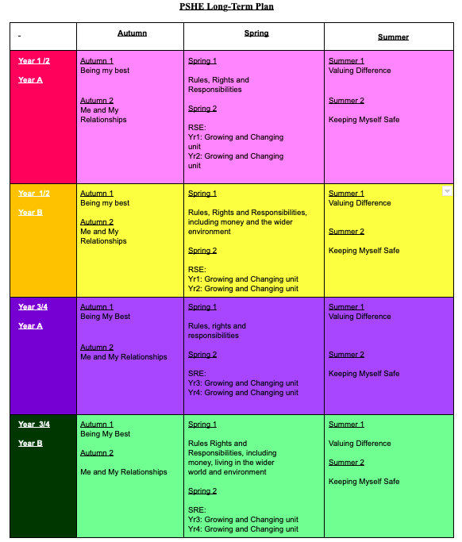
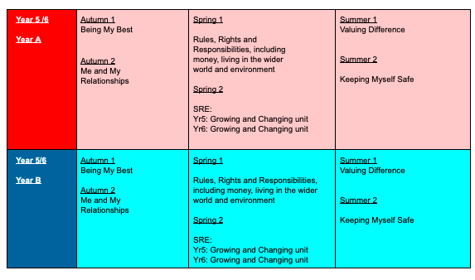
End of Unit Assessment
At the end of each unit that has been delivered the teachers will carry out the end of unit assessments- these can be found on both of the websites. An example of medium term planning can be found on the website where assessments for each lesson are outlined.

Key Stage Progression Assessment
Below is the document for key stage progression- teachers will be able to see the previous learning of year groups in order to adapt and develop their teaching.
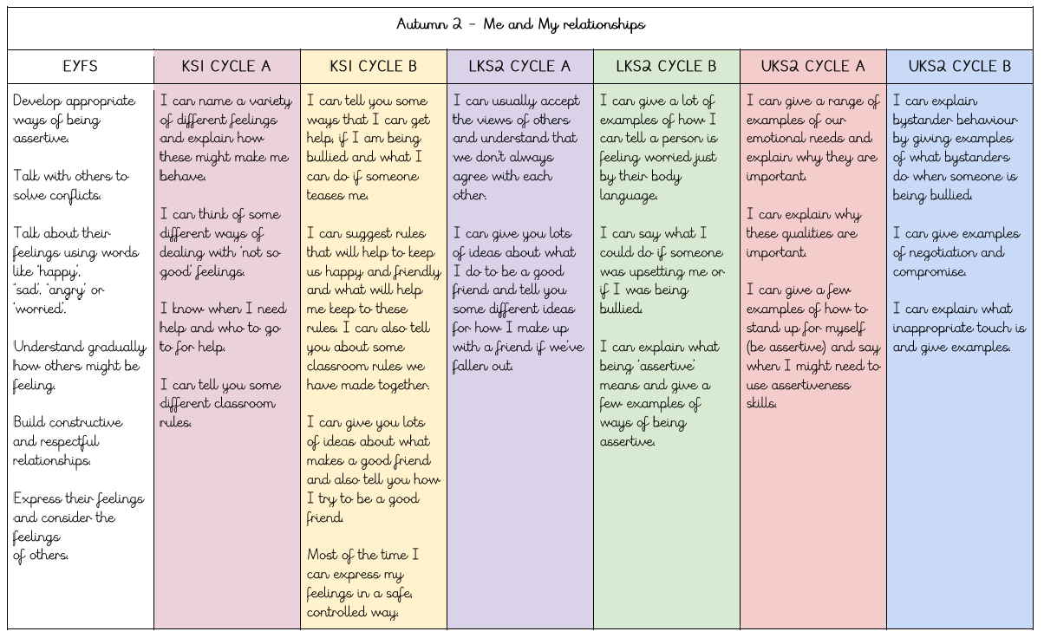
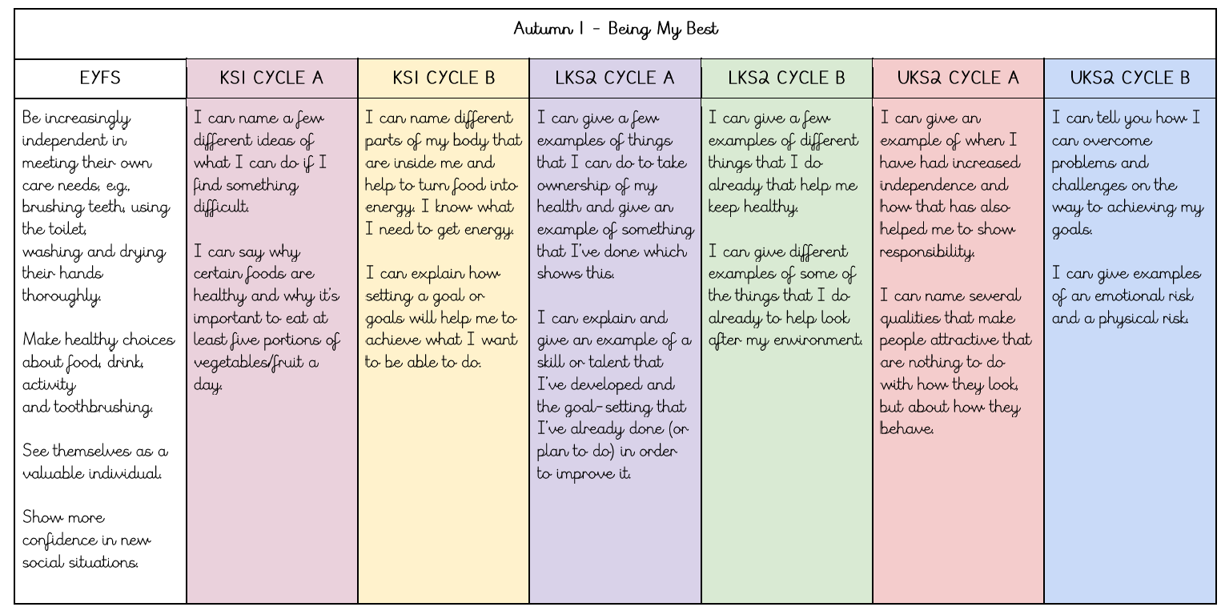

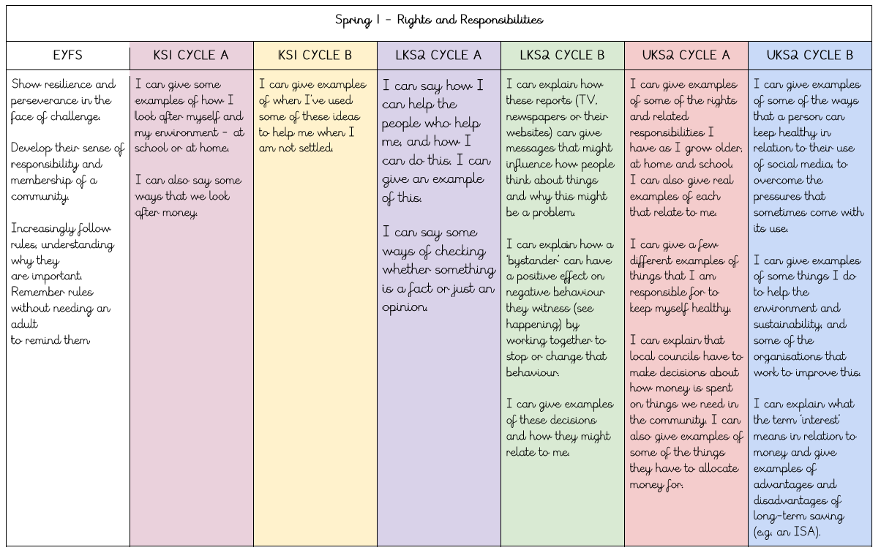

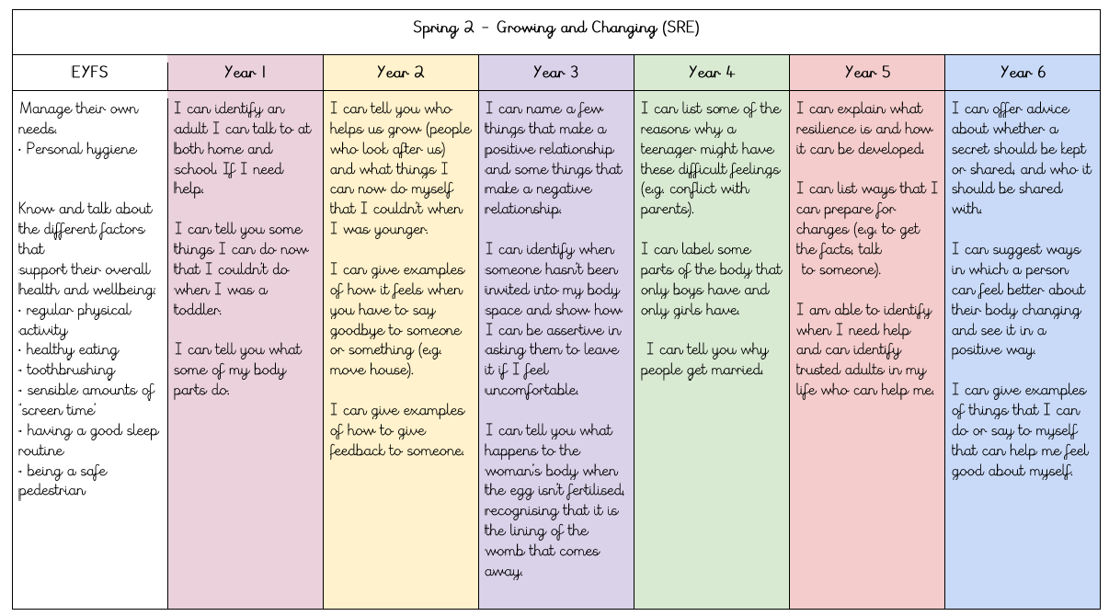

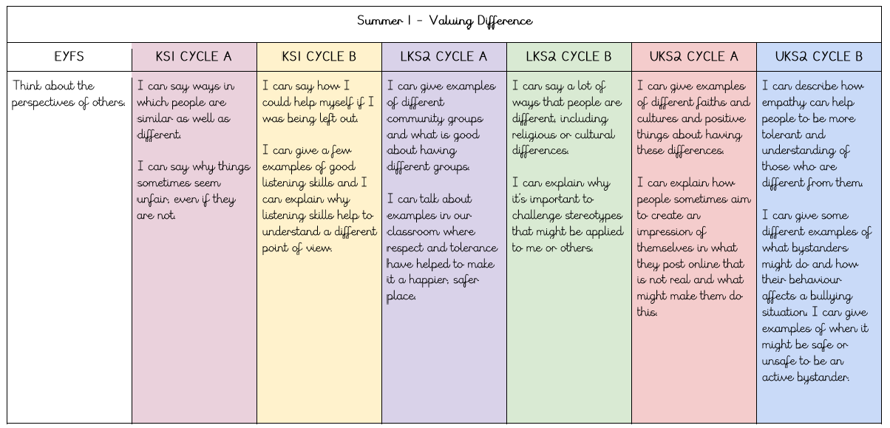
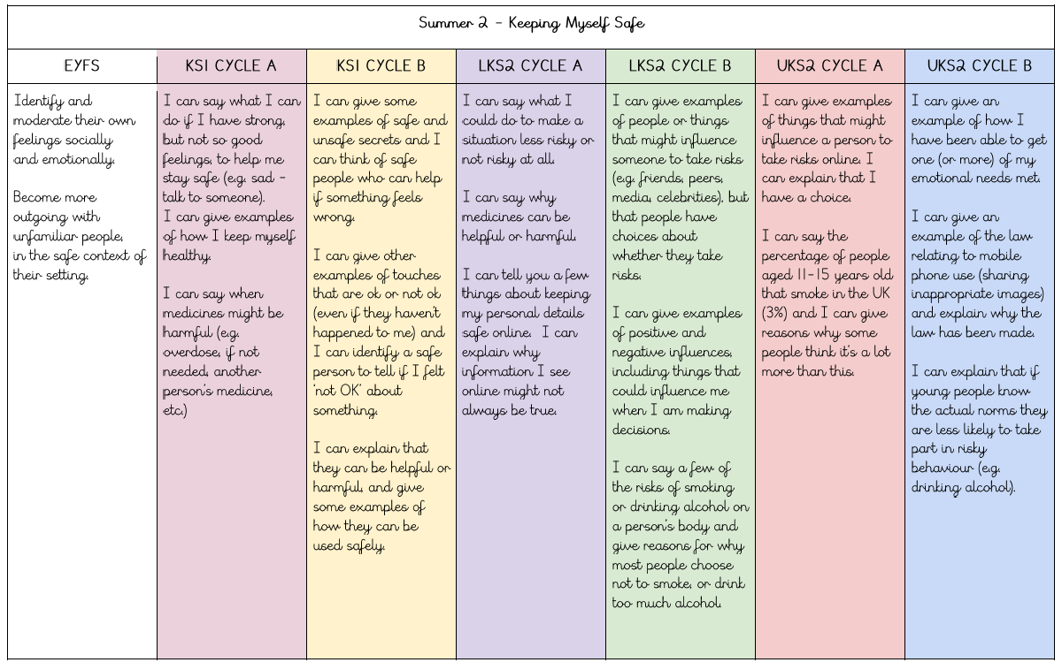

How should PSHE be taught? What makes it unique?

PSHE is a unique subject in that it deals with the personal, social and health of individuals, as well as sex and relationships education. It is the way in which we can support the development of the whole child.

PSHE should be taught through carefully planned discussion and practical activities. Written tasks and outcomes should be carefully considered in PSHE- we want to develop pupils as individuals who can both recognise and identify key aspects of the curriculum, but also articulate these to their peers and are confident in discussions and debates. Of course, individual reflection is also important, and this may be best recorded individually, but how and when pupils are asked to record in PSHE needs thought and attention.

Useful Resources
https://campaignresources.phe.gov.uk/schools/resources/building-connections-year6-lesson-plan-pack Building Relationships UKS2

https://www.cresst.org.uk/resource/ks1-ks2-free-resources/
Friendships EYFS KS1

https://anti-bullyingalliance.org.uk/sites/default/files/uploads/attachments/Anti-Bullying%20Week%202021%20-%20Primary%20School%20Pack%20-%20FINAL%20_1.pdf
Bullying KS1 and KS2

https://www.thinkuknow.co.uk/professionals/
Online Safety All year groups

https://www.internetmatters.org/schools-esafety/parent-online-support-pack-teachers/
E-Safety All year groups

https://pshe-association.org.uk/
Useful Resources

https://learning.nspcc.org.uk/safeguarding-child-protection-schools
Useful Resources in terms of Safeguarding

