Our Pillars of Music
Intent
At Grove we are guided by the National Curriculum for Music (2014).
The National Curriculum for music aims to ensure that all pupils:
- perform, listen to, review and evaluate music across a range of historical periods, genres, styles and traditions, including the works of the great composers and musicians
- learn to sing and to use their voices, to create and compose music on their own and with others, have the opportunity to learn a musical instrument, use technology appropriately and have the opportunity to progress to the next level of musical excellence
- understand and explore how music is created, produced and communicated, including through the inter-related dimensions: pitch, duration, dynamics, tempo, timbre, texture, structure and appropriate musical notation
The music curriculum at Grove Primary School aims to foster a love , passion and enjoyment of music.
Implementation
The music curriculum ensures children sing, listen, play, perform and evaluate. This is embedded in the classroom through the structured music programme Music Express as well as the Monthly Musician of the Month assemblies, various concerts and performances, individual lessons, musical clubs and teaching from specialist music teachers.
The elements of music are taught in the classroom lessons so that children are able to use some of the language of music to dissect it, and understand how it is made, played, appreciated and analysed. In the classroom children learn key aspects of music through cross-curricular links. They also learn how to compose, focusing on different dimensions of music, which in turn feeds their understanding when listening, playing, or analysing music. Composing or performing using body percussion and vocal sounds is also part of the curriculum, which develops the understanding of musical elements without the added complexity of an instrument.
Our music curriculum uses Music Express as a resource to cover our Key Concepts of the music curriculum:
Structure
Notation
Performing
Composing
Beat
Pitch
Exploring Sounds

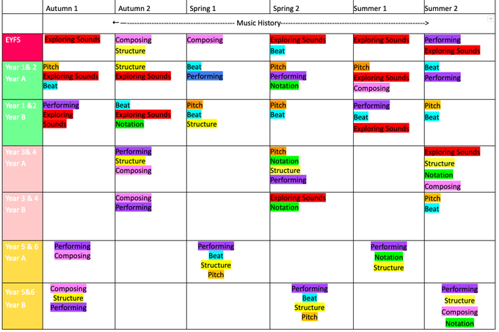
As well as this, we aim to offer other musical opportunities for our children. These include:
- Whole class ukulele lessons for Year 3
- Individual/group guitar and ukulele lessons
- Rock Choir
- Opportunities for performances in the local area

EYFS
The development of children’s artistic and cultural awareness supports their imagination and creativity. It is important that children have regular opportunities to engage with the arts, enabling them to explore and play with a wide range of media and materials. The quality and variety of what children see, hear and participate in is crucial for developing their understanding, self-expression, vocabulary and ability to communicate through the arts. The frequency, repetition and depth of their experiences are fundamental to their progress in interpreting and appreciating what they hear, respond to and observe.
Development Matters 2021:
A Guide to using Music Express
Step 1
Refer to Key Stage Medium Term Plan document on Google Drive to find current music unit.
Step 2:

Log into Music Express

https://connect.collins.co.uk/school/Portal.aspx?s1=0
Step 3
Select Lesson Bank, then your year group
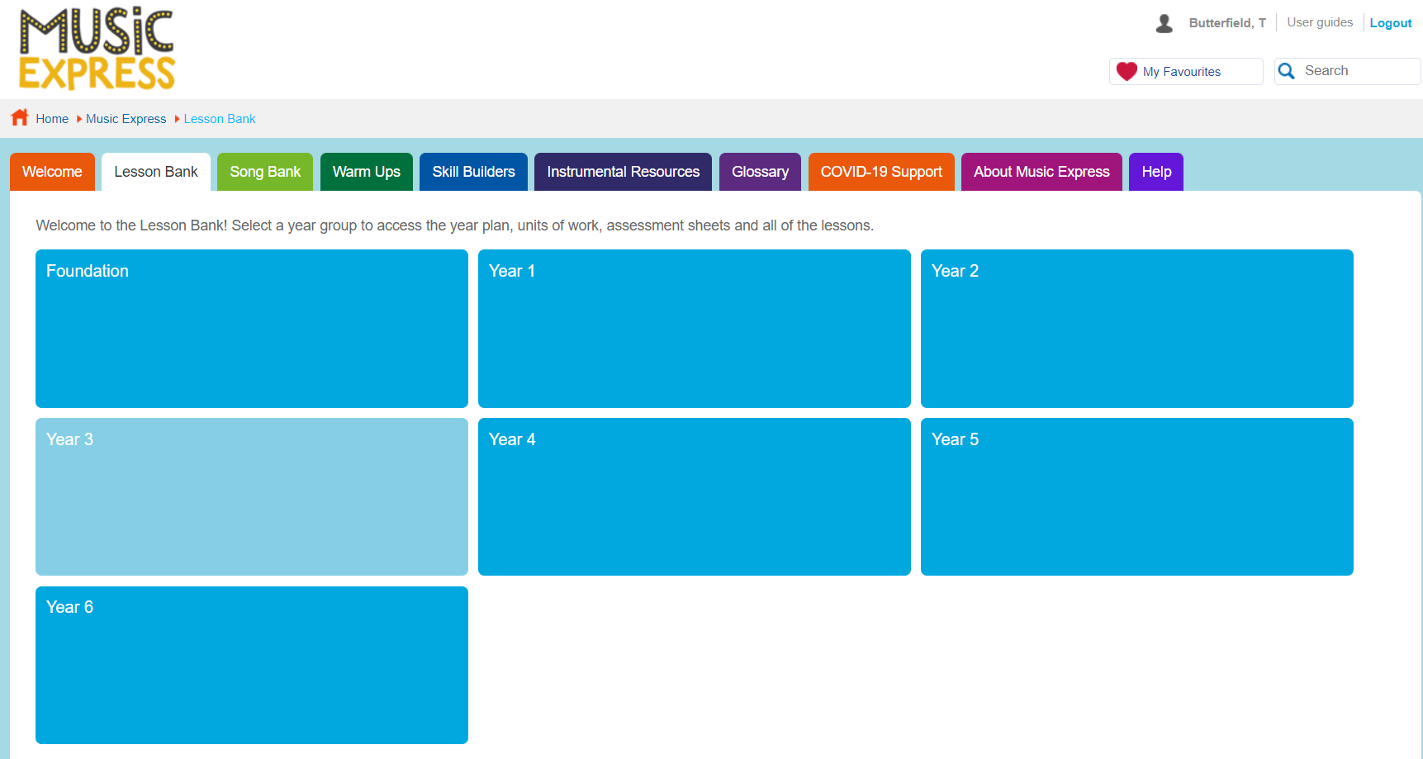Select current unit

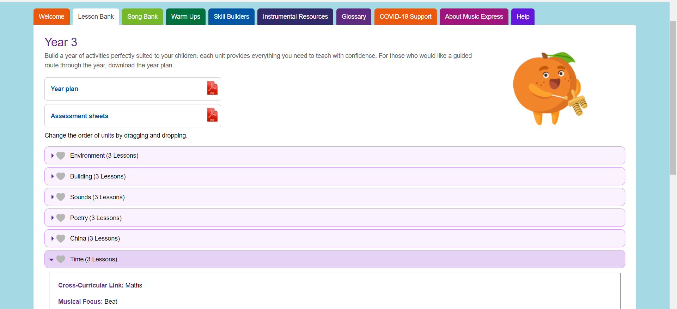
Step 4

Please ensure you read through the lesson plan available.
- You will need to consider resources, space and time.
- You will need to adapt the plan in relation to your class’s needs, planning differentiation where appropriate.
- Ensure your lesson starts with one of the warm-ups

Implementation
Pupils should leave Grove Primary equipped with a range of skills to enable them to succeed in their secondary education and be able to enjoy and appreciate music throughout their lives.

