Art and Design Handbook
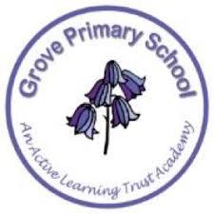

Contents
- Our Vision (Intent)
- Expectations for teaching Art & Design
- Non-Negotiables
- Long term plan
- Concept map
- National Curriculum
- Curriculum Knowledge, Skills and Technical Vocabulary
- Glossary

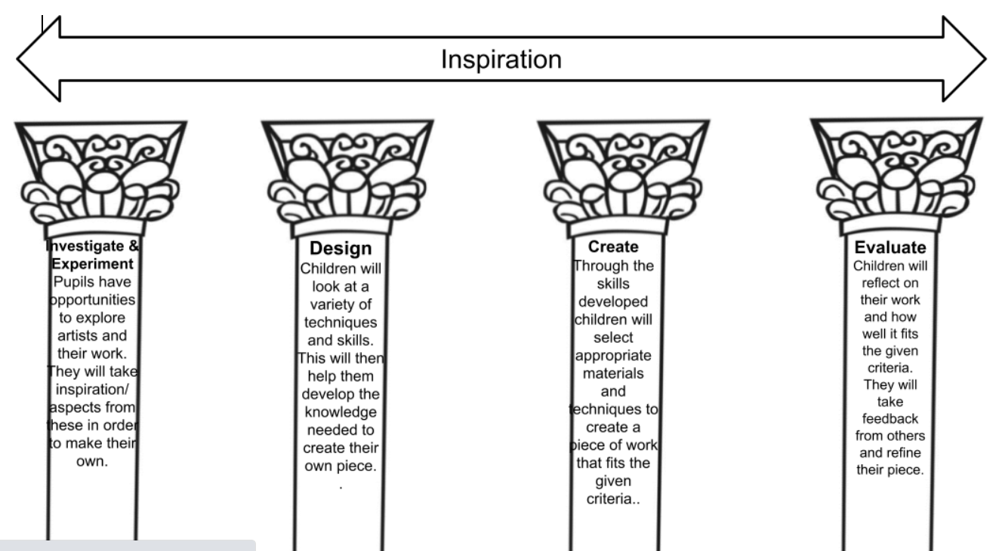
Art and Design Pillars
Interests and talents
Broader Development
Voice

Our Vision
At Westwood and Grove Primary schools we value Art and Design and the opportunities that it provides for our children to be creative and to express themselves. This is a key part of the children’s entitlement to a broad and balanced curriculum. We have carefully designed and structured our art curriculum to ensure children develop the knowledge and skills needed to be successful artists.

Children will be given a range of experiences including; drawing, painting, printmaking, collage, textiles and 3D. The art curriculum has been structured to support children to be able to think critically and develop a more rigorous understanding of art and design. As children progress through the school, the art curriculum allows them to build upon prior knowledge and skills, giving them opportunities to apply them to a new context. In order to prepare them for their future art teaching will also support the children to develop key learning behaviours: resilience, risk taking, resourcefulness, relationships and reflection.

Through hands on experiences we aim to create a love of art in which children as artists are inspired by famous artists, have opportunities to develop techniques using a range of mediums and can talk about their work. At Westwood and Grove Primary schools we aim for children to leave Year 6 with the knowledge, skills and a love of art which will enable them to creative individuals as they grow.

Expectation for teaching Art and Design

- Staff to foster a love of the Arts which include art appreciation and practical activities
- Children to be immersed into an artist and their work
- Long term plans are followed
- Plans are annotated, differentiated and personalised
- Taught on a half termly basis
- Over a two yearly cycle children will experience a variety of arts which focuses on learning new skills and knowledge
- Formative assessment is used to move children’s learning forward during the lesson and to develop next steps
- Sonar is completed on a termly basis and data is used to identify gaps/trends/focus groups

Requirements for teaching Art
- All units in books to have a front page.
- All work to have a knowledge and skills LO which includes BAE
- Work to be code marked using B A E by children and staff
- When code marking include whether children worked I, SH or H.
- Use self and peer assessment for children’s reflections. This can be on post it notes. EG. What went well, what they could improve.
- Where possible, work straight into sketch books. If working on paper, work to be trimmed before being stuck in.
- Equipment and resources are used responsibly and are developmentally appropriate
- Where possible allow children to choose resources, size/colour of paper etc.

Photos
- General photos to be used in class book not individual children’s books.
- Only photos which include the child and their work to be used in individual children’s Art books.
If it is a lesson which isn’t in individual books it needs to be in the class book. Photos, pupil voice to show what the children have learnt.

Long term plan
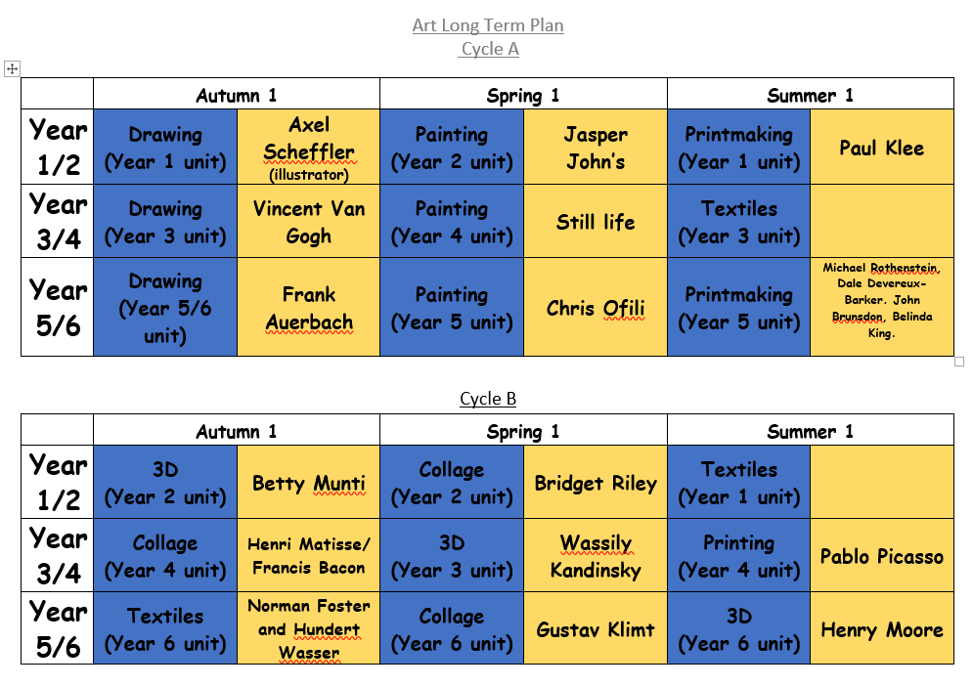
Art and Design teaching follows the Suffolk Art Plan scheme.
Teachers create short term plans and personalise each lesson to ensure progression of skills and class needs are met.

Assessment is completed and is uploaded to Sonar half termly.

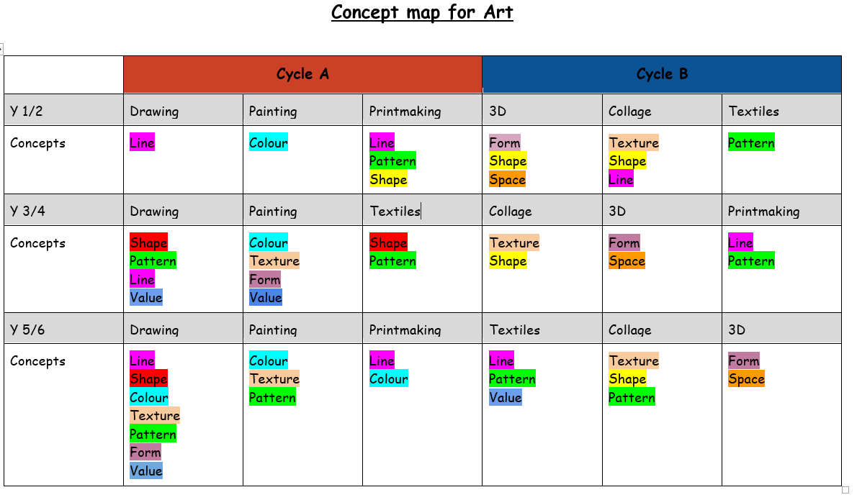

Art and Design
Drawing  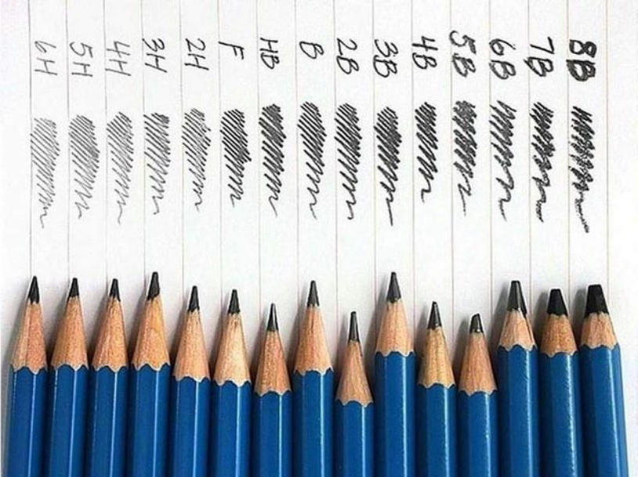 | 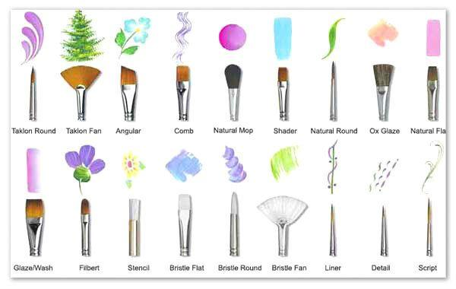  Painting
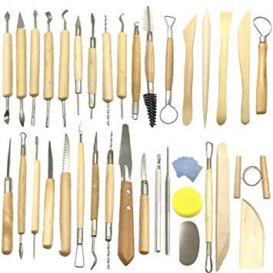  3D | Collage  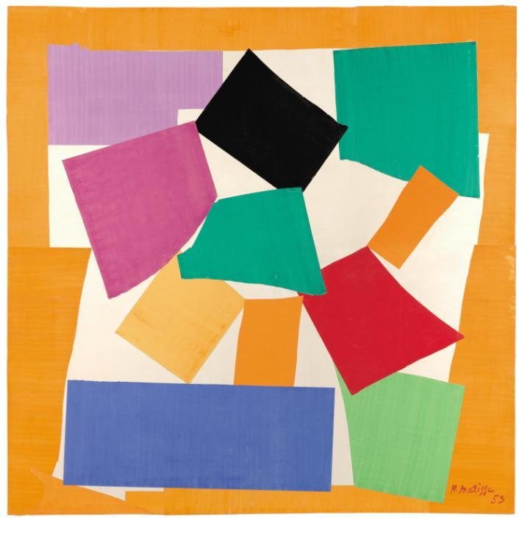
Printing  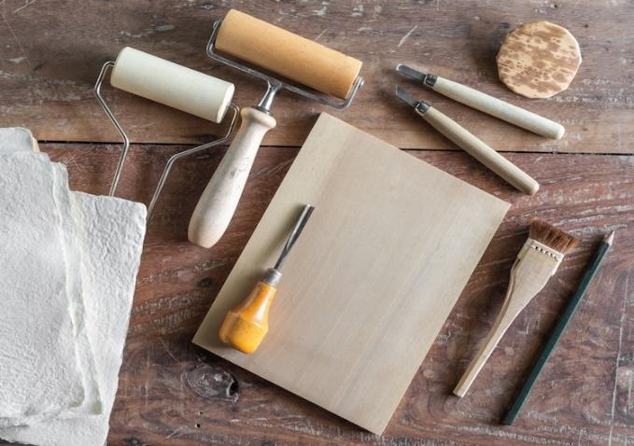 | 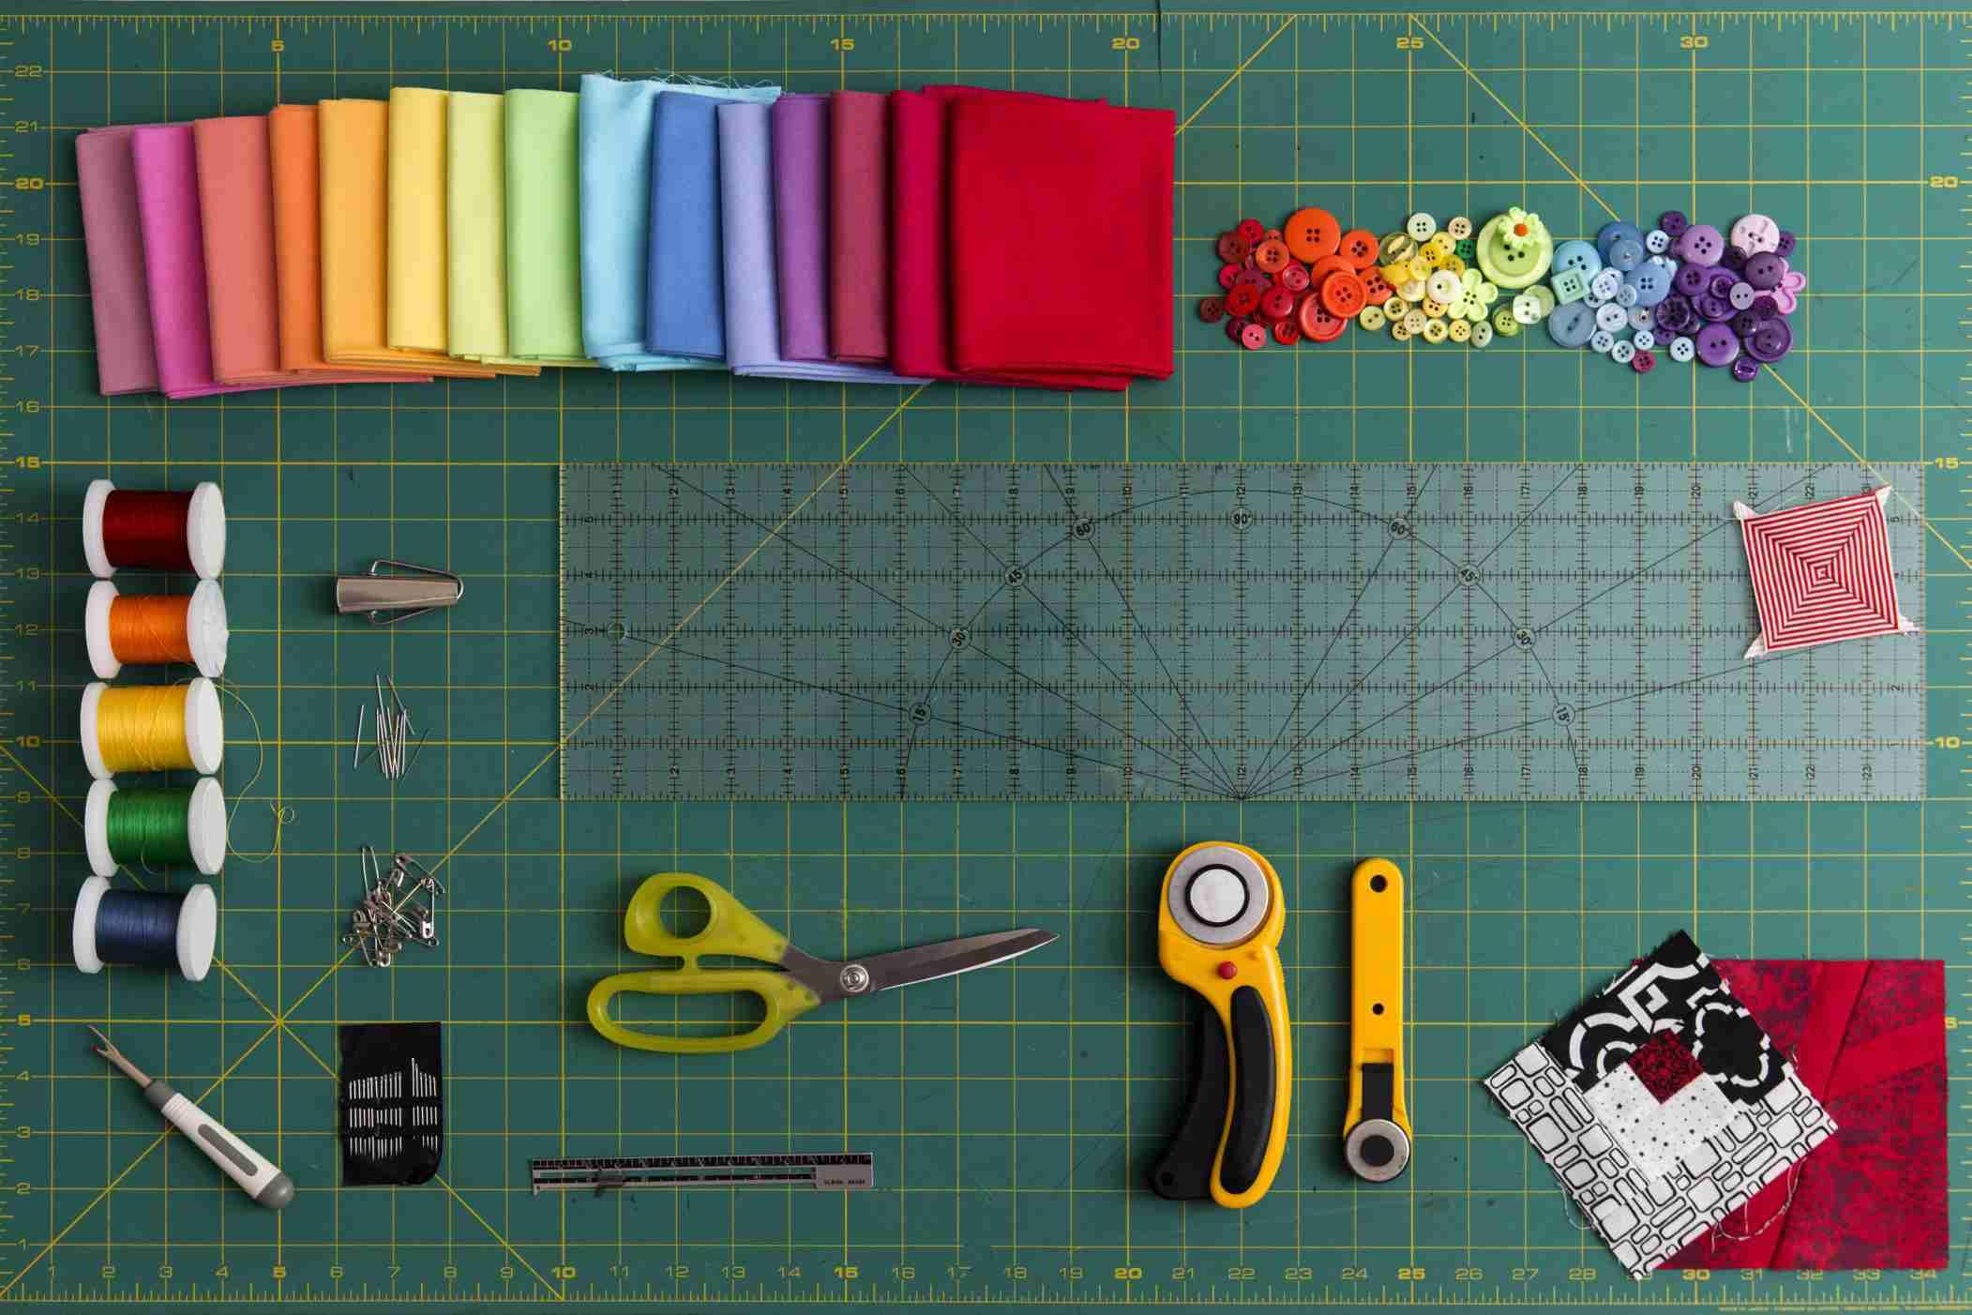  Textiles

National Curriculum
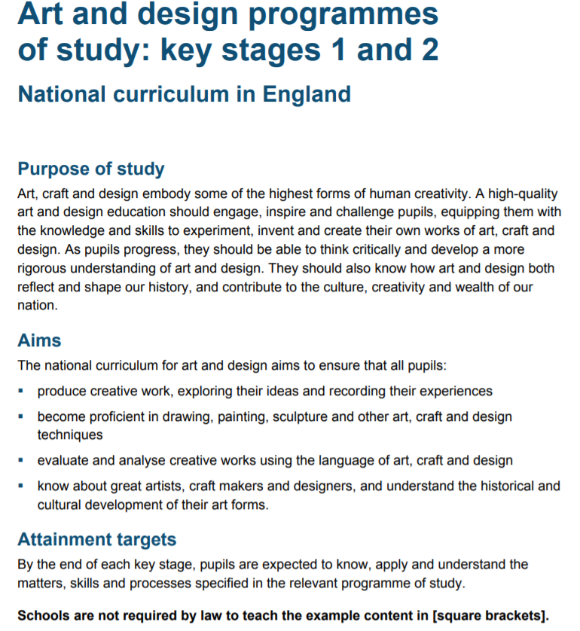

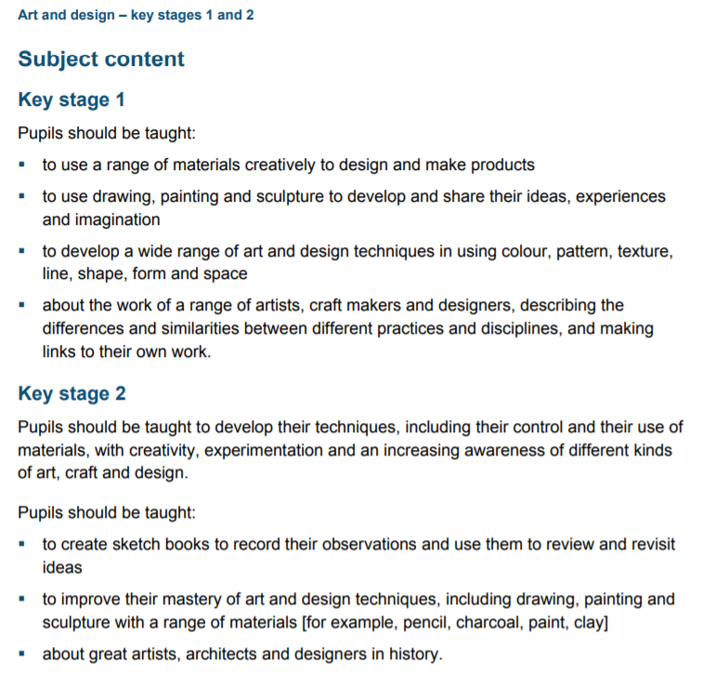

Art and Design Skills, Knowledge and Technical Vocabulary
 |  | Learning Objective |  |  | Knowledge  (National Curriculum) | Skills | Technical Vocabulary (based on Suffolk Art units)
End of KS1 |  | To develop ideas |  |  | Use experience and ideas as inspiration for artwork | Respond to ideas and starting points.  Explore ideas and collect visual information.  Explore different methods and materials as ideas develop. | Strengths  Weaknesses  Improve  Starting point
 |  | To master techniques | Painting |  | Know that different media (material techniques) can be combined to create different and new effects within a range of contexts. | Use different sized brushes and good control to produce different results.  Use primary and secondary colours and justify reasons for choices.  Add white and black to create tones. | Primary colours  Secondary colours  Tints 7  Tones  2d shapes  Line  Pattern  Space  Marsh  Jump  Collage  Primary colours
 |  |  | Drawing |  | To know that different pressures and different pencils can create different lines.  To know that different effects can be used when creating sketches. | To experiment with altering the thickness of lines.  To create effect by using a mixture of dots, lines and shading.  (To create tones?) | Media techniques  Pattern  Texture  shading
 |  |  | 3D Sculpture |  | To know that art is not 1 dimensional. (3D). | Combine shapes including lines and textures (rolled up paper, straws, paper, card and clay.)  To select and techniques needed to shape assemble and join materials such as rolling, cutting, moulding and carving. | Aboriginal  Symbol  Represents  Earth  Colours  Surface  Slab  Inlay  Rolling  Firming  Pinching  pulling
 |  |  | Collage |  | To know that different materials can create different effects. | Experimenting combining different materials.  To sort and arrange materials effectively. | Cut  Torn  Glue  Texture  Combine
 |  |  | Textiles |  | To know that weaving and twisting creates a pattern.  To know that materials can be joined together in different ways. | Use weaving to create a pattern.  Join materials using glue and or stitch.  Use plaiting.  Use dip dye techniques. | Bleed  Overlap  Over and under.
 |  |  | Printing |  | To know that patterns can be created from repeating shapes.  To know and recognise a range of prints within their environment (wall paper, bark etc.). | Use repeating or overlapping shapes. Press, roll rub and stamp to make prints.  Mimic print from the environment.  Use objects to create prints such as fruit, vegetable or sponges. | Print  Dabbing  Stroking  Tone  Darker/lighter  Slab
 |  | To take inspiration from the greats (classic and modern) |  |  | To know the names of some famous artist and their work. | Describe the work of artist.  Use artists work and techniques to inspire their own work. | Modern artists  Classic artists
End of LKS2 |  | To develop ideas |  |  | Use experience and ideas as inspiration for artwork | Respond to ideas and starting points.  Explore ideas and collect visual information.  Explore different methods and materials as ideas develop. | Strengths  Weaknesses  Improve  Starting point
 |  | To master techniques |  | Painting | to improve their mastery of art and design techniques, including drawing, painting and sculpture with a range of materials [for example, pencil, charcoal, paint, clay] | Use a number of brush techniques, using thick and thin brushes to produce shapes, textures, patterns and lines.  Mix colours effectively  Use water colour paint to produce washes for backgrounds then add detail | Brush strokes  Light/dark  Tone  Contrast  Repeated  Observe  Enlarge  Reflect  Moistened  Wash
 |  |  |  | Drawing |  | Use shading to show light and shadows  Use hatching and crosshatching to show tone and texture  Sketch lightly  Use different hardness of pencils to show line, tone and texture.  Annotate sketches to explain and elaborate ideas | Mark  Line  Pattern  Tone  Pressure  Light/dark  Hatching  Brusho  Resist  Highlight  Pattern  Repeated  Enlarge
 |  |  |  | 3D Sculpture |  | Create and combine shapes to create recognisable forms  Include texture that conveys feelings, expression or movement | Gummed tape  Layer  Form  Decoration  Cylinder  Transfer  Slab  Terrocotta  Coil  Roll
 |  |  |  | Collage |  | Select and arrange materials for a striking effect  Ensure work is precise | Position  Arrange  Motion  Torn  Overlapping  Distortion  Transposing  Adapt  Unique
 |  |  |  | Textiles |  | Shape and stitch materials  Use basic cross stitch and back stitch  Some participation in dying fabric | Pattern  Design  Folding  Collograph  Assemble  Rotation  Reflection  Rollers  symmetry
 |  |  |  | Printing |  | Use layers of two or more colours  Make printing blocks  Make precise repeating patterns | Design  Scratching  Pressure  Process  Adapt  Modify  Indented  Linear  Transpose
 |  | To take inspiration from the greats (classic and modern) |  |  | To know about great artists, architects and designers in history | Describe the work or notable artists, artisans and designers  Use some of the ideas of artists studied to create pieces
End of UKS2 |  | To develop ideas |  |  | Use experience and ideas as inspiration for artwork | Respond to ideas and starting points.  Explore ideas and collect visual information.  Explore different methods and materials as ideas develop. | Strengths  Weaknesses  Improve  Starting point  Evaluate  Modify
 |  | To master techniques |  | Painting | to improve their mastery of art and design techniques, including drawing, painting and sculpture with a range of materials [for example, pencil, charcoal, paint, clay] | Sketch lightly before painting to combine line and colour  Use the qualities of watercolour and acrylic paints to create visually interesting pieces.  Combine colours, tones and tints to enhance the mood of the piece.  Use brush techniques and the qualities of paint to create texture.  Develop a personal style of painting, drawing upon ideas from other artists. | Layers  Abstract  Linear  Acetate  Transpose  Layered  Vibrant  Unrealistic  Contrasting  Expressive  Adjacent  Fabric  Tonking
 |  |  |  | Drawing |  | Use a variety of techniques to add interesting effects. E.g. reflections, shadows, direction of sunlight  Use a choice of techniques to depict movement, perspective, shadows and reflection.  Choose a style of drawing suitable for the work E.g. realistic or impressionistic | Line  Shape  Colour  Texture  Tone  Pattern  Form  Portrait  Mosaic
 |  |  |  | 3D Sculpture |  | Show lifelike qualities and reallife proportions or, if more abstract, provoke different interpretations.  Use tools to carve and add shapes, texture and pattern | Maquette  Pinching  Pulling  Stroking  Smoothing  Pendant  Decoration  Series  Scale  Assemble  Positioning  modification
 |  |  |  | Collage |  | Mix textures rough and smooth, plain and patterned. | Patterning  Layering  Linear  Spiral  Dimension  Cubist  2d and 3d  Figurative  Composition
 |  |  |  | Textiles |  | Show precision in techniques  Combine previously learned techniques to create pieces | Layering  Construction  Hanging  Fixing  Assembly  Folding  pinching  scrunching  sliding  resist  layers  textures
 |  |  |  | Printing |  | Use a range of visual elements to reflect the purpose of the work  Build up layers of colour, create an accurate pattern showing fine detail | Press print  Incisions  Inverted  Combination  Linear  Response  printmaker
 |  | To take inspiration from the greats (classic and modern) |  |  | To know about great artists, architects and designers in history | Give details about the style of some notable artists, artisans and designers  Show how the work of those studies was influential in both society and to other artists  Create original pieces that show a range of influences and styles.

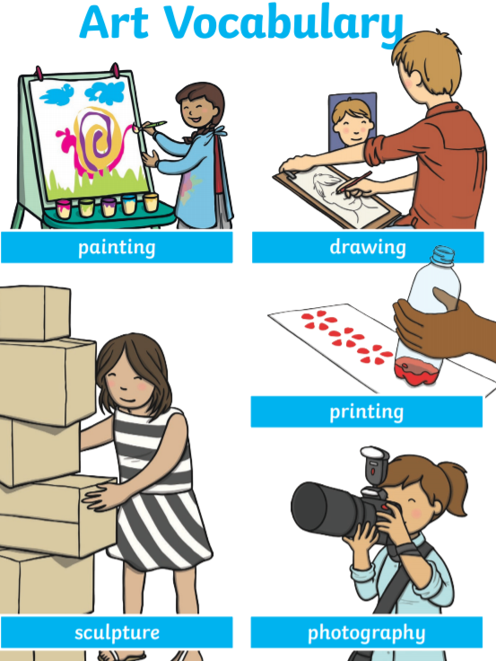
Picture Glossary
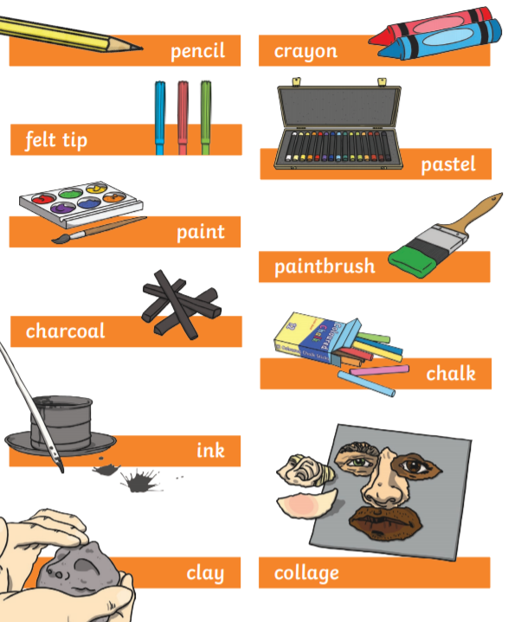

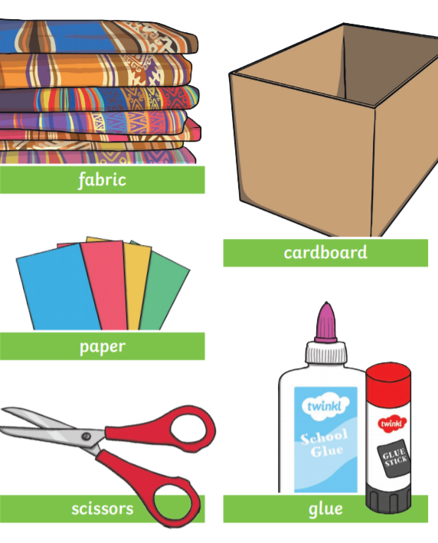
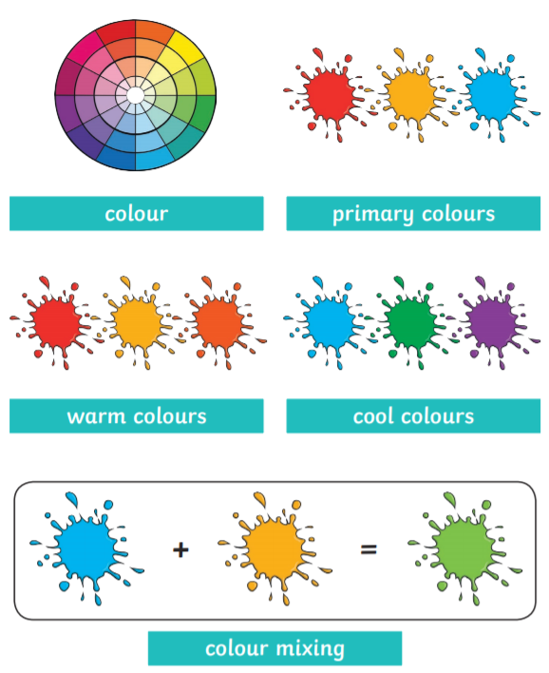

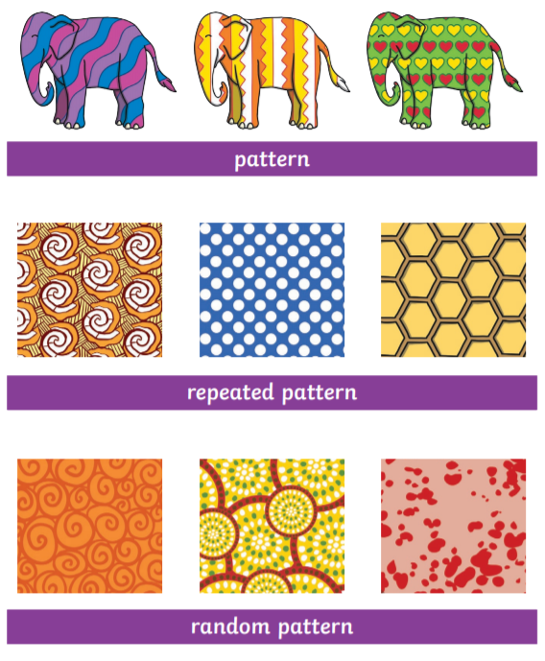
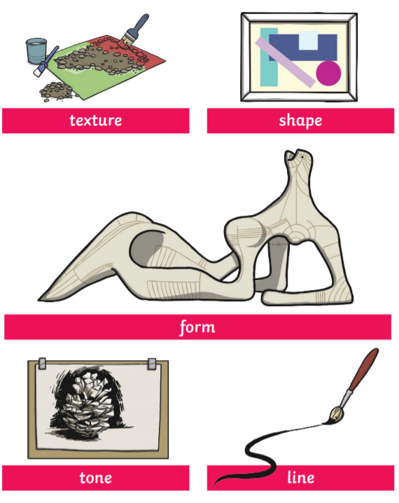

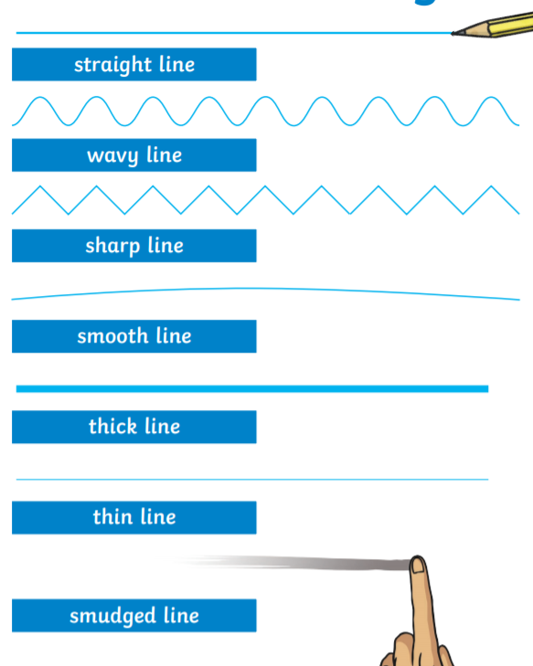
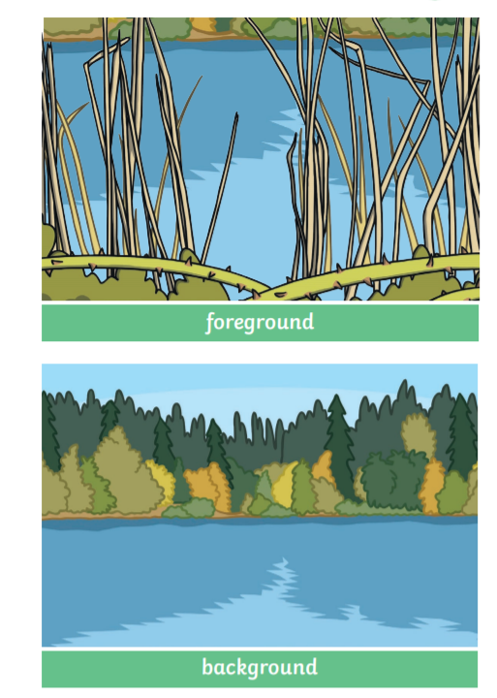

Glossary List cont.
Acrylic - a paint or colour containing acrylic resin
Airbrush - an atomizer for spraying paint or varnish by means of compressed air
Brush - a device made of bristles, hairs, wires, etc, set into a firm back or handle: used to apply paint, clean or polish surfaces
Canvas - a piece of canvas or a similar material on which a painting is done, usually in oils
Chalk - used for writing and drawing
Charcoal - a black amorphous form of carbon made by heating wood or other organic matter in the absence of air: used for drawing in the form of a stick or pencil
Crayon - a small stick or pencil of charcoal, wax, clay, or chalk mixed with coloured pigment
Drawing paper - paper that is specially made for drawing on
Easel -a frame, usually in the form of an upright tripod, used for supporting or displaying an artist's canvas, blackboard, etc
Fixative - a fluid usually consisting of a transparent resin, such as shellac, dissolved in alcohol and sprayed over drawings to prevent smudging
Glaze - a semitransparent coating applied to a painting to modify the tones
Ground- the background of a painting or main surface against which the other parts of a work of art appear superimposed
Ink - a fluid or paste used for printing, writing, and drawing
Oil paint - paint made of pigment ground in oil, usually linseed oil, used for oil painting
Paint - a dry film of paint on a surface
Paintbrush - a brush used to apply paint
Palette- a flat piece of wood, plastic, etc, used by artists as a surface on which to mix their paints
Palette knife - a round-ended spatula with a thin flexible blade used esp by artists for mixing, applying, and scraping off paint, esp oil paint
Pastel - a substance made of ground pigment bound with gum, used for making sticks for drawing
Pencil - an artist's fine paintbrush
Sketchbook - a book of plain paper containing sketches or for making sketches in
Spatula - a utensil with a broad flat, often flexible blade, used for lifting, spreading, or stirring foods or paints, etc
Watercolour - the art or technique of painting with such pigments

Places to Visit for Art
Pakefield Art Gallery
Number 36 Art Work Shop (Bell’s Road)
Sainsbury Centre Norwich
Ferini Gallery Lowestoft

