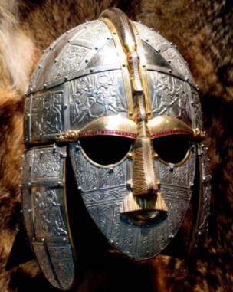
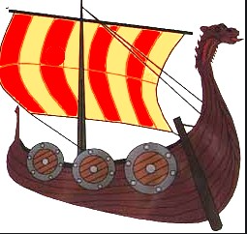
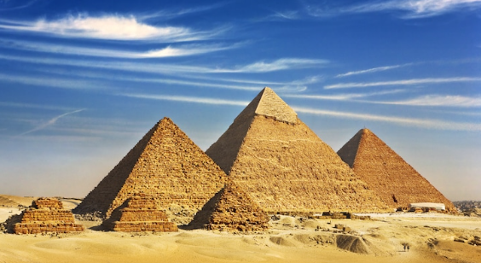
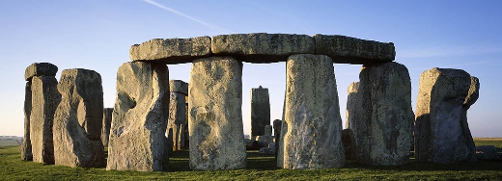
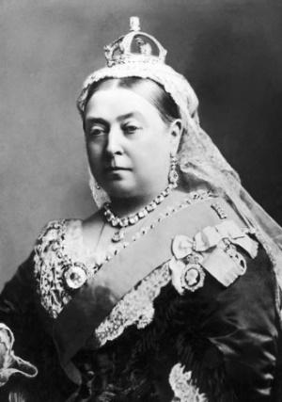
History Handbook
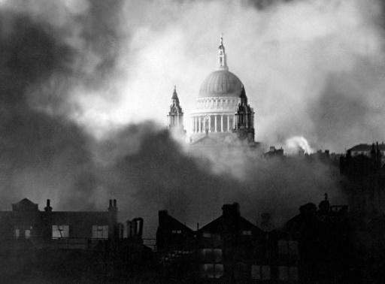
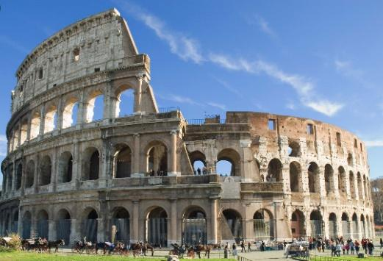

Contents Page
Page 3- History Pillars
Page 4 - Grove and Westwood’s Intent for History
Page 5 - Non-Negotiables
Page 6-7 – Long term plan
Page 8-9 – Concept plan
Page 10-11 - Assessment
Page 12 – Useful websites

History Pillars
History lessons are underpinned by our History pillars in order to not only provide children with knowledge but also develop historical skills, allowing them to know more and do more, and encourage children to work as historians. History units are planned to ensure that lessons are built upon the key ideas in the History pillars and units always work towards children developing this knowledge and skills.

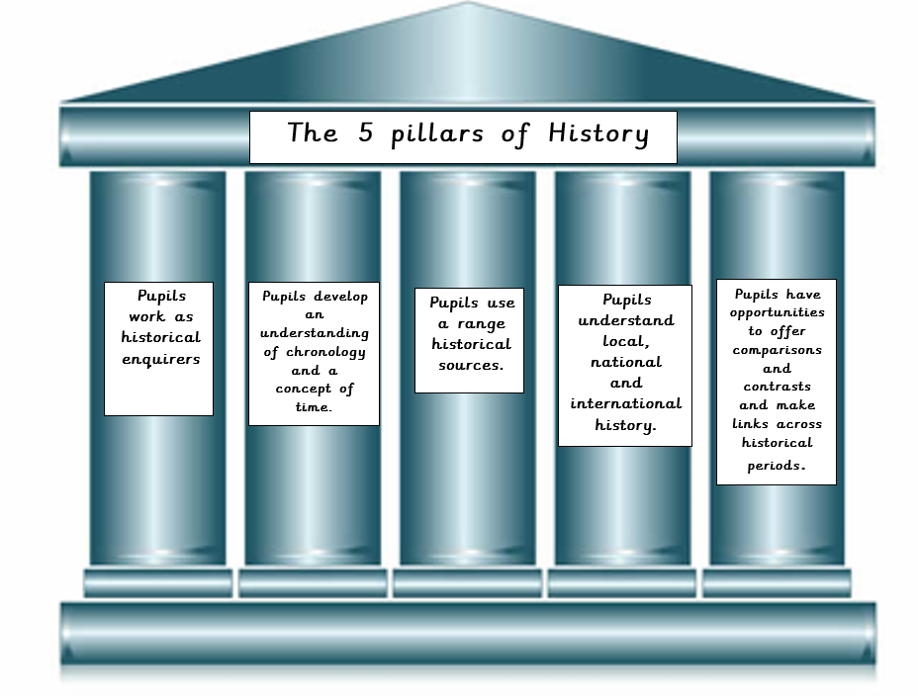

Grove and Westwood’s Intent for History
At Grove and Westwood, we aim to give our children an opportunity to learn the skills required to become a historian. As a historian, each pupil will be provided with an opportunity to gain historical content, ask the appropriate questions and have access to the materials required to put forward an answer.
Our history curriculum will give our pupils an insight into local, national and international history. Whilst studying each unit of History, the children will develop a greater understanding of chronologically. In order to develop an enquiry mind-set, our pupils will have access to historical sources from the start of their schooling throughout their journey to Year 6. We will teach our children the skills required to find out about the past by ensuring that they carry out appropriate research and analysis of primary and secondary sources. Wherever possible, to expand their historical thinking, we will make visits to historical sites and museums.
History will be a driving force to inspire other lessons in a cross-curricular fashion. We will use technical vocabulary and allow historical concepts to seep through in our writing and maths topics. The skills that are taught within History are qualities that we will install in pupils to create an enthusiastic, inquisitive, life-long learner.

Non-Negotiables
1. Each learning block to have two Learning Objectives. One for the historical context and the other for what historical skill is being taught.
2. DUMTUMS followed. This could be typed or a combination of written and typed – where the date is written and the Learning Objectives typed.
3. Each learning block to have a Skills for Life attached to it.
4. The children are aware that they are in a history class, with a focus on ‘As a historian I can/am …’
5. Children to have a good understanding of historical content, with the ability to recall key facts.
6. There to be a working timeline visible in each phase area – where children will place their work in the correct chronological place.
6. Pupils to be taught the skills required to be a historian – and be aware that they are being taught this skill. Please refer to the 5 pillars of History.
7. History lessons to be feature a range of activities that include kinaesthetic, visual and auditory learning.
8. Pupils encouraged to be inquisitive learnings who will enjoy their own learning journey.

Long Term Plan

 | Cycle A |  |  | Cycle B
Year 1/2 | What was life like when our grandparents were children? | How have holidays changed over time? | How did the first  flight change the world? Why were the Rainhill Trials important? | Did the Great Fire make London a better or worse place? | Mary Seacole and Florence Nightingale: Why should we remember these key figures? | Who are our local heroes?
National Curriculum | Changes within living memory | Changes within living memory | Events beyond living memory that are significant nationally or globally. | Events beyond living memory that are significant nationally or globally. | Significant people. | Changes within living memory
Year 3/4 | Who are our local black heroes? | How has Crime and Punishment  changed over time? | What happened when the Romans  came to Britain? | How much did the Ancient Egyptians achieve? | What was new about the New Stone Age? | Which was more impressive – the  Bronze Age or the Iron Age?
National Curriculum | A local history study.  Significant people. | A study of an aspect British history that extends pupils’ chronological  knowledge beyond 1066. | Changes in Britain. | The achievements of the earliest civilizations. | Changes in Britain.
Year 5/6 | Did WWI or WWII have the biggest  impact on our locality? | Journeys - what makes people go on a journey? | Ancient Greeks - what did the Greeks do for us? | The Anglo-Saxons and The Vikings -  Vicious warriors or peaceful settlers? |  | Why should we remember the  Mayans?
National Curriculum | A local history study. |  | A study of Greek life and achievements and their influence on the  western world. | Settlement.  The struggle for the Kingdom of England to the time of Edward the Confessor. |  | A non-European society that provides contrasts with British history

Key Concept plan
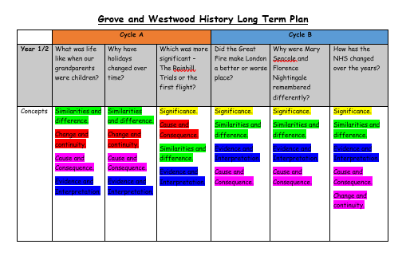
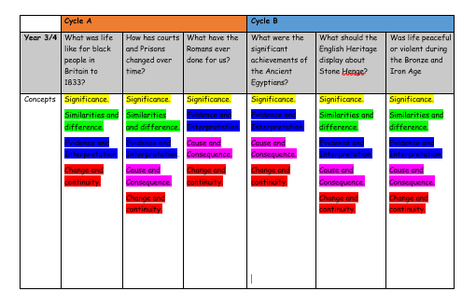
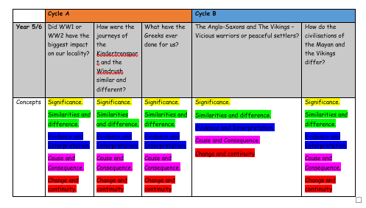

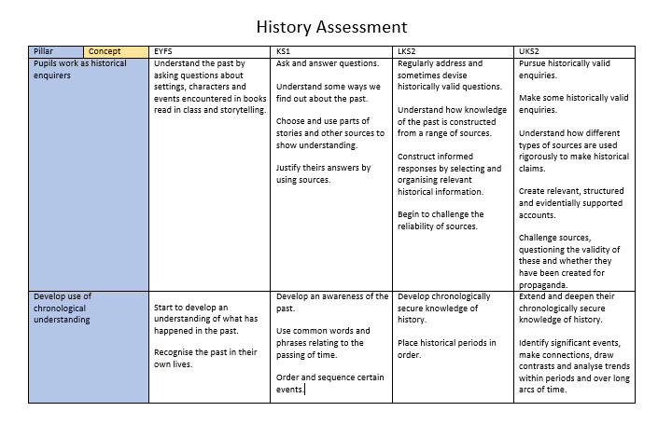

Holidays – Knowledge Organiser

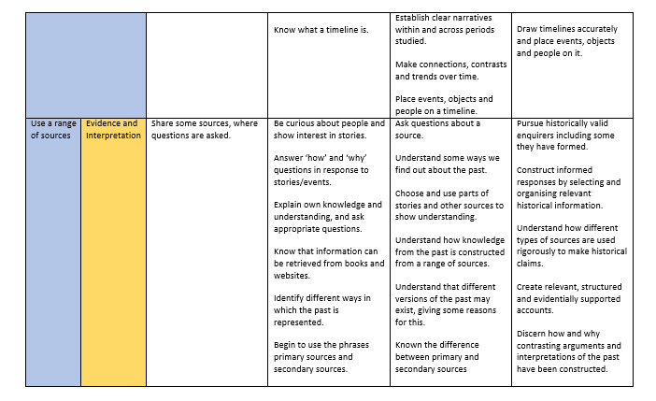

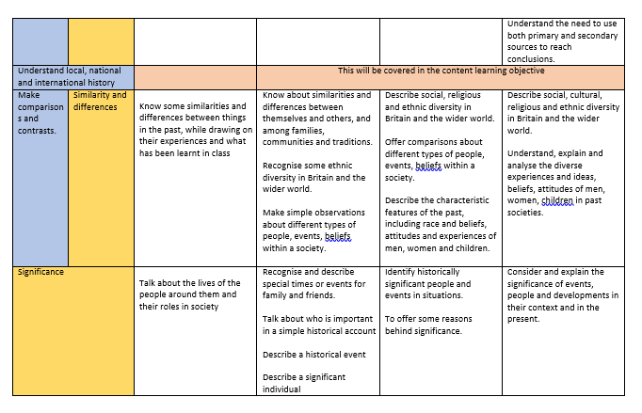

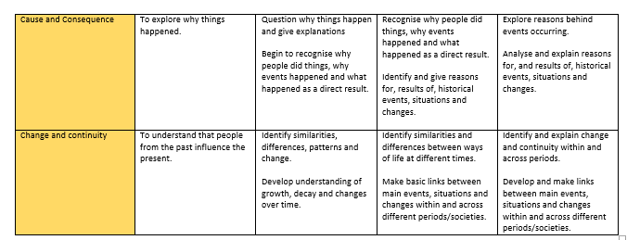

Useful websites:
Historical Association - https://www.history.org.uk/

https://www.bbc.co.uk/bitesize/subjects/zcw76sg

Key Stage 2 - https://www.ks2history.com/

http://teachinghistory100.org/

https://www.keystagehistory.co.uk/primary-history/ - Need to subscribe

https://www.teachitprimary.co.uk/history

https://www.educationquizzes.com/ks1/history/ - KS1 and KS2 quizzes

https://www.webanywhere.co.uk/education/teaching-resources/primary/history

https://www.theschoolrun.com/

