PSHE KNOWLEDGE ORGANISER Year 6
Growing and Changing
Overview of lesson objectives |  | Books and websites to support
In this unit, you will learn:  Lesson 1 :  - To recognise how society views “perfect”and “normal”  - Identify other qualities in others as well as their looks and challenge gender portrayals.  Lesson 2:  - To define the word puberty and give examples of the changes associated with it.  - Suggest strategies that would help someone who felt challenged by these changes.  Lesson 3:  - To define the word puberty and give examples of the changes associated with it.  - Identify the changes that happen through puberty.  Lesson 4:  - To know a variety of ways in which the sperm can fertilise the egg to create a baby;  - Identify the changes that happen through puberty to allow sexual reproduction to occur  Lesson 5:  - To understand the risks of sharing images online  - Recognise that people can feel pressured for different reasons |  | 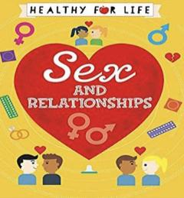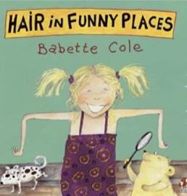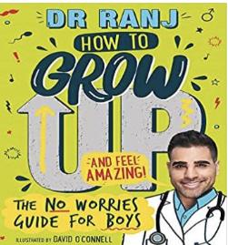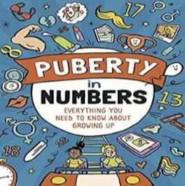  https://childrenshealthsurrey.nhs.uk/services/advice-talking-your-children-years-5-6-about-puberty  https://www.bbc.co.uk/bitesize/guides/znxnscw/revision/6
Content of Lessons
Lesson 1 - What is perfect? | Lesson 3- How does my body change? |  | Diagrams for Lesson 4
- We will discuss what the media portrays as “perfect” and think about unrealistic beauty standards (photoshopping, surgery etc.) | - We will discuss why we go through puberty.  - We will talk about the different ways that our bodies change such as hips widening, eggs being released, sperm being released, and erections happening, and ejaculation.  - We will discuss the different hormonal changes that occur during puberty and how to handle these.  - We will begin to discuss how this allows for adults to make a baby. |  | 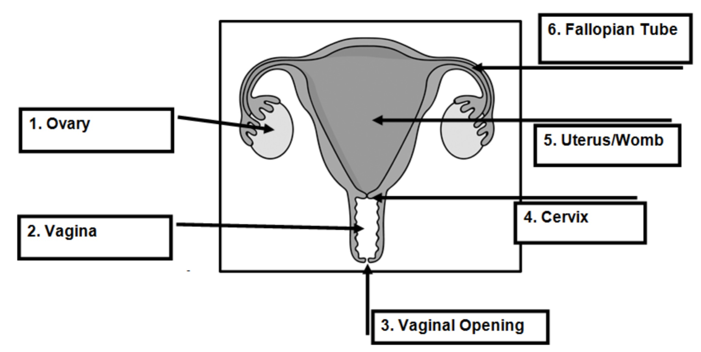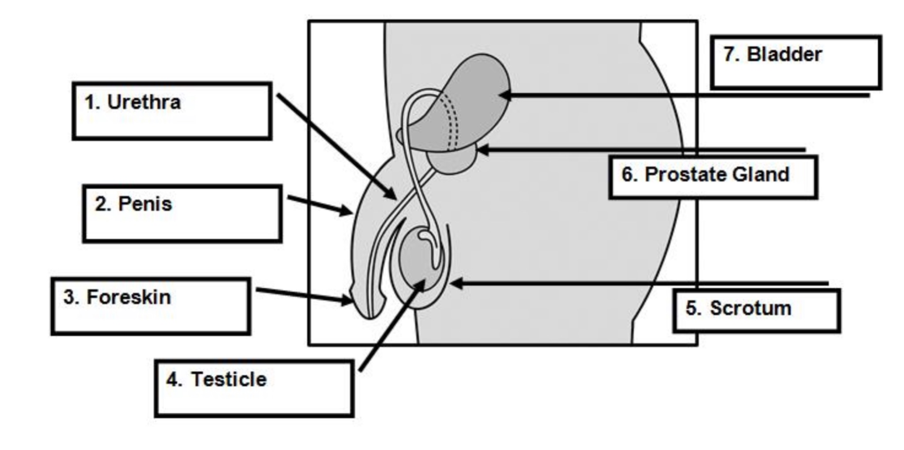
Lesson 2 - What is puberty? | Lesson 4 - How are babies made? |  | Lesson 5 - Should I share the photo?
- We will recap what puberty is and discus the challenges and changes that occur during this period.  - We will recap the menstrual cycle and different products available to support this.  - We will look at a range of true/false statements about puberty. | - We will label the different parts of the reproductive system.  - We will explain that most babies are created when a man and a woman have sexual intercourse. Emphasise that this usually happens when a man and woman are in a loving relationship and agree to make a baby. This is when the sperm of the man meets with the egg of the woman inside the woman’s body.  - We will look at a pregnancy timeline.  - We will discuss different legal facts around pregnancy and other options of having a baby. |  | - We will discuss different scenarios that may occur when someone might ask someone else to share photos of themselves online.  - We will talk about how to deal with these situations.  - We will highlight the consequences of sharing inappropriate photos online.  - We will talk about the importance of keeping private parts private.
KEY VOCAB
Tampons Sanitary pads Puberty Hormones Vagina Penis Menstrual cycle Pubic hair Foreskin Anus Testicle Scrotum Ejaculation Fallopian tube Reproduction Uterus

Vocabulary and definitions
cervix | The plug at the end of the vaginal passage and the start (neck) of the uterus
Fallopian tubes | 2 tubes which the ova (eggs) travel along to reach the uterus (womb).
genitals | Name given to all the external sexual organs
Gender expression | How a person shows their gender by the way they act, behave, dres etc.
Gender identity | How a person feels about themselves in their head. Whether they feel they are a boy or girl or neither
Hair | Body hair appears around the genitals first (pubic hair) and then grows under the  arms and on the legs. Young men also grow hair on their chest and face.
IVF | Where specialist doctors fertilise the egg of the woman with the sperm of the man, but outside of the body. The fertilised egg creates an embryo which is then put back inside the woman so she becomes pregnant and grows the baby inside her uterus/womb.
Labia | Includes both the smaller lips/folds of skin that surround the entrance to the vagina and urethra (wee hole), and the outer lips/folds of skin that surround the inner lips.
menstruation | Another word for periods. A loss of blood (usually monthly) as the unused ovum (egg) comes out of the vaginal opening along with the lining of the uterus.
ovary | where the ova (eggs) are kept. There are usually two.
puberty | Emotional and physical changes that happen in early adolescence, as the body begins to mature sexually and develop.
penis | This is the shaft shaped reproductive organ that hangs outside the male body. An organ that can help transport urine (wee) and sperm away from the body.
Sexual reproduction | Occurs when a male sex cell (sperm) and the female sex cell (egg) join. This fusion of sex cells is called fertilisation. Sexual reproduction allows some of the genetic information from each parent to mix, producing offspring that resemble their parents, but are not identical to them. In this way, sexual reproduction leads to variety in the offspring.
scrotum | Sack or pouch which hold testicles. During puberty the scrotum becomes baggy, helping the testicles to hang away from the body. This helps to keep the temperature down, which allows sperm to be produced.
testicles | Also known as ‘balls’, these are held in the scrotum (sack/ball bag) found below the penis, which produce millions of sperm every day.
urethra | The tube which runs from the bladder to the outside of the body, either through  the penis or to an opening above the entrance to the vagina. It also carries sperm to the penis.
uterus | A fertilised egg (one that has joined a sperm) embeds itself into the lining of the uterus and grows into a baby. If this doesn’t happen the lining of the uterus comes away as part of a period and renews itself for the next month.
vagina | The opening of the reproductive part of the girl’s body (the passage which leads to the womb).
vulva | Vulva refers to the external parts of the girl’s genitals which you can see.

