PSHE KNOWLEDGE ORGANISER Year 4
Growing and Changing
Overview of lesson objectives |  | Books and websites to support at home
In this unit, you will learn:  Lesson 1 :  - To describe some of the changes that happen during our lives  - Suggest people who may be able to help us deal with change  Lesson 2:  - To understand how puberty affects my emotions  - Suggest reasons why young people sometimes fall out with their parents  Lesson 3:  - To identify parts of the body that males and females have in common and those that are different  - Understand and explain why puberty happens  Lesson 4:  - To know the key facts of the menstrual cycle  - Identify ways that girls manage their periods.  Lesson 5:  - To understand that marriage includes same sex and opposite sex partners  - Discuss the reasons why a person would want to be married, live together or have a civil ceremony. |  | 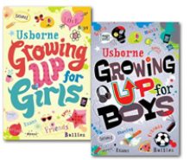  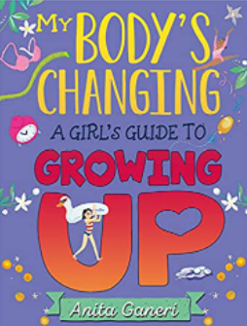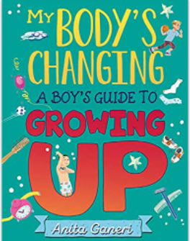
Content of Lessons
Lesson 1 | Lesson 2 |  | Lesson 3
-We will be looking at things that have changed for them since last year and how some of these things may be more challenging than others  -We will think about changes that could happen suddenly and how we could seek help and support with these. | -We will talk about the different emotions we may feel in puberty and how hormones affect this.  -We will talk about how to compromise with someone if you have a conflict with another person. |  | -We will write down body parts on an outline that men and women have in common and will then talk about the differences between a female and male.  -We will use the correct terms for ‘private parts’ as penis and vulva.  -We will look at why puberty happens - in order to start reproducing to have babies.
Lesson 4 |  |  | Lesson 5
-We will look at the male and female organs on the diagrams attached.  -We will recap periods from Year 3 and look at products (such as tampons and pads ) that may be used.  -We will know the key facts of the menstrual cycle. | 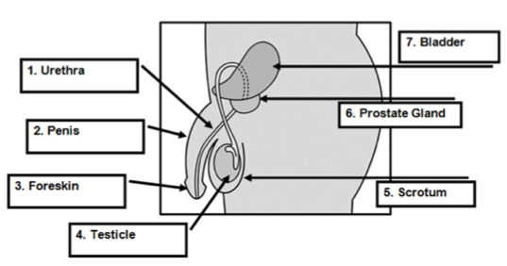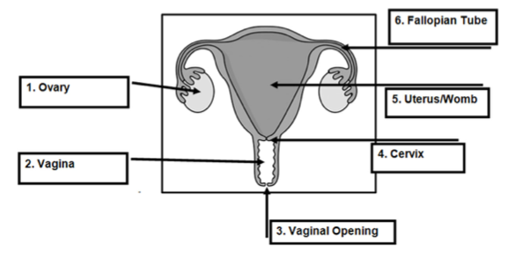 |  | -We will look at reasons why couples choose to get married.  -We will talk about how the laws and how this has changed .
KEY VOCAB
sperm egg reproductive organs puberty ovaries testicles penis foreskin scrotum urethra fallopian tube vagina vulva cervix uterus/womb hair genitals fertilise periods sanitary towels tampons menstrual cycle

Vocabulary and definitions
cervix | The plug at the end of the vaginal passage and the start (neck) of the uterus
Fallopian tubes | 2 tubes which the ova (eggs) travel along to reach the uterus (womb).
genitals | Name given to all the external sexual organs
Hair | Body hair appears around the genitals first (pubic hair) and then grows under the  arms and on the legs. Young men also grow hair on their chest and face.
IVF | Where specialist doctors fertilise the egg of the woman with the sperm of the man, but outside of the body. The fertilised egg creates an embryo which is then put back inside the woman so she becomes pregnant and grows the baby inside her uterus/womb.
menstruation | Another word for periods. A loss of blood (usually monthly) as the unused ovum (egg) comes out of the vaginal opening along with the lining of the uterus.
ovary | where the ova (eggs) are kept. There are usually two.
puberty | Emotional and physical changes that happen in early adolescence, as the body begins to mature sexually and develop.
penis | This is the shaft shaped reproductive organ that hangs outside the male body. An organ that can help transport urine (wee) and sperm away from the body.
Sexual reproduction | Occurs when a male sex cell (sperm) and the female sex cell (egg) join. This fusion of sex cells is called fertilisation. Sexual reproduction allows some of the genetic information from each parent to mix, producing offspring that resemble their parents, but are not identical to them. In this way, sexual reproduction leads to variety in the offspring.
scrotum | Sack or pouch which hold testicles. During puberty the scrotum becomes baggy, helping the testicles to hang away from the body. This helps to keep the temperature down, which allows sperm to be produced.
testicles | Also known as ‘balls’, these are held in the scrotum (sack/ball bag) found below the penis, which produce millions of sperm every day.
urethra | The tube which runs from the bladder to the outside of the body, either through  the penis or to an opening above the entrance to the vagina. It also carries sperm to the penis.
uterus | A fertilised egg (one that has joined a sperm) embeds itself into the lining of the uterus and grows into a baby. If this doesn’t happen the lining of the uterus comes away as part of a period and renews itself for the next month.
vagina | The opening of the reproductive part of the girl’s body (the passage which leads to the womb).
vulva | Vulva refers to the external parts of the girl’s genitals which you can see.

