PSHE KNOWLEDGE ORGANISER Year 1
Growing and Changing
Overview of lesson objectives |  | Books and websites to support at home
In this unit, you will learn:  Lesson 1 :  - What is inside our body?  Lesson 2:  - How do you take care of a baby.  Lesson 3:  - What changes have happened since you were a baby?  Lesson 4:  - What is private?  Lesson 5:  - Is it a surprise or a secret. |  | 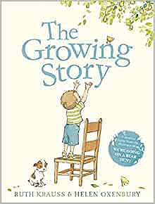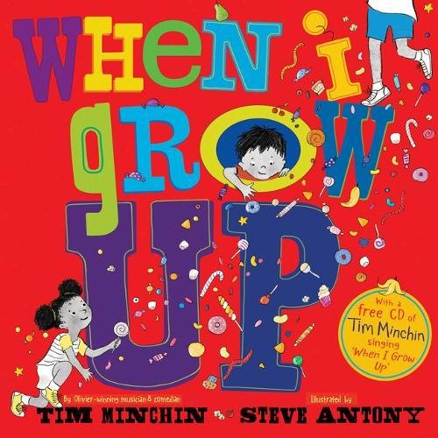  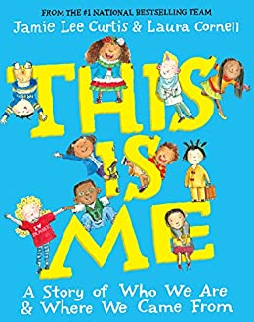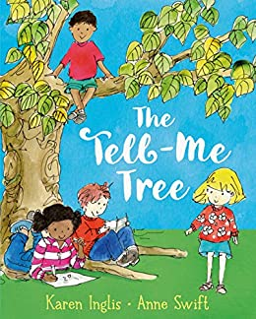
Content of Lessons
Lesson 1 | Lesson 2 |  | Lesson 3
- To name major internal body parts.  - Understand and explain simple bodily processes.  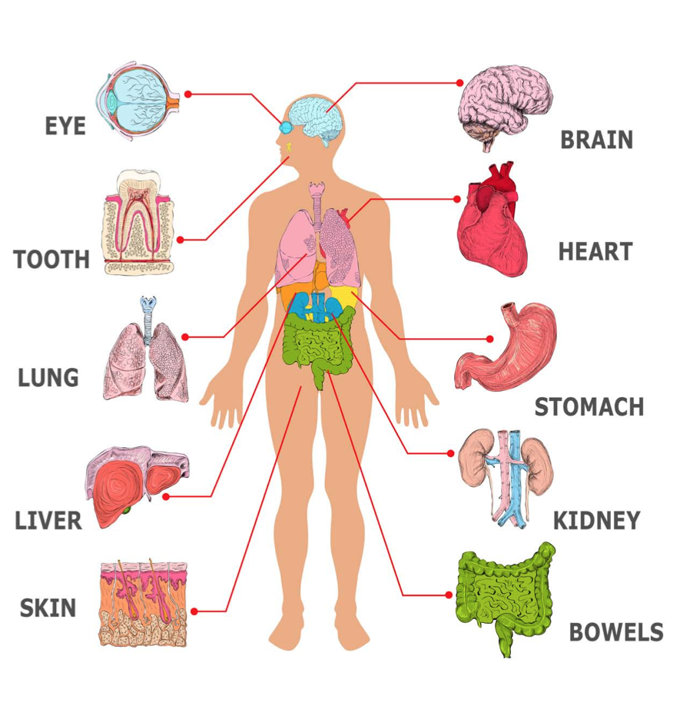 | - To understand some of the tasks required to look after a baby.  - Explain how to meet a baby's needs. |  | - To identify things that you could do as a baby to now.  - Identify the people who help us at different stages.
Lesson 4 | Lesson 5 |  | Key vocab
- To identify parts of the body that are private.  - Describe ways in which private parts can be kept private. | - To identify secrets or surprises.  - Identify who they can talk to if they feel uncomfortable. |  | - Good and bad touch

