Westwood Primary School
Grove Primary School

Geography Handbook

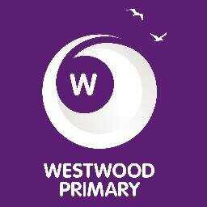
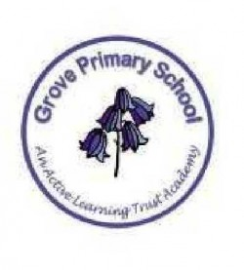

Contents Page

Page Number

Geography pillars 3
Curriculum Intent 4-5
Non-Negotiables 6
Our Geography 7 Key Concepts 7
Long Term Plans 8
Assessment 9 - 14
Useful websites and links 15
Visits and local contacts 16

Our Schools Geography Pillars

These 5 pillars underpin what geography will like across both our schools. These 5 key principles will be taught each year and will steer teachers planning and assessment. These are our curriculum goals we want each child to achieve by the end of year 6

- Develop the pupils as geographical enquirers
- To develop an understanding of local, nation and international geography.
- Develop the use geographical sources
- To develop fieldwork skills to gather hands on geographical experiences.
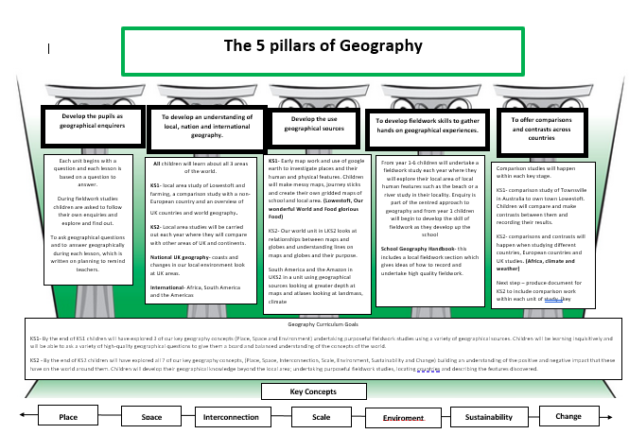
- To offer comparisons and contrasts across countries

Grove and Westwood’s Intent for Geography
At Grove and Westwood, we aim to give our children an opportunity to learn the skills required to become a geographer. As a geographer, each pupil will be given the tools to develop their own cultural awareness, understand and resolve issues about their environment and recognise the importance of sustainable development. The children will be inspired to think about their own place in the world, their values, and their rights and responsibilities to other people and the environment.

At Westwood and Grove we aim to:

• Develop a broad geographical and cultural awareness of globally significant places.
• Provide opportunities for children to undertake geographical enquiry and utilise skills by investigating and expressing their own views about people, places and environments, both in and outside the classroom.
• Enable children to communicate their view points in a variety of ways using appropriate vocabulary.
• Encourage children to collect and analyse evidence and draw conclusions.
• Explore a range of sources of information.
• Foster enjoyment, satisfaction and curiosity for finding out about places, patterns and processes.

Geography curriculum

In Key Stage 1 as children begin to work at National Curriculum levels. Year 1 and 2 children will focus on 4 areas: Locational knowledge, Place knowledge, Human and Physical geography and Geographical skills and fieldwork. They will investigate their local area and a contrasting area in a non-European country. They will name, locate and identify characteristics of the four countries and capital cities of the UK. They will be taught to name and locate the world’s seven continents and five oceans. In doing this they will ask geographical questions about people, places and the environment and learn simple mapping skills. This will be achieved through topic work with strong cross curricular links. Speaking and listening skills will be utilised and improved as the children begin to develop a broader cultural awareness and an understanding the viewpoints of others.

In Key Stage 2, Geography will be taught through 4 areas: Locational knowledge, Place knowledge, Human and Physical geography and Geographical skills and fieldwork. Each year group will focus on one geographical topic during the year. These will often link with their learning in other curriculum areas. Each topic will develop geographical skills and enquiry through active learning. Children will learn the necessary skills to investigate a variety of people, places and environments at different scales and will begin to make links between different people and places in the world. Children will begin to recognise and explain patterns made by individual physical and human features in the environment and explain how these can cause changes. They will also learn to name and locate countries and cities of the UK; the worlds countries especially Europe and North and South America.

Sustainable development is a strand that continues through each year group. By the end of key stage 2, children will have has the opportunity to recognise how people can improve the environment and will discuss how and why people seek to manage environments sustainably.

Geography will be a driving force to inspire other lessons in a cross-curricular fashion. We will use technical vocabulary and allow geographical concepts to seep through in our writing and maths topics. The skills that are taught within Geography are qualities that we will instil in pupils to create an enthusiastic, inquisitive, life-long learner.

Our intent is that our teaching of Geography will help pupils gain a coherent knowledge and understanding of their locality, Great Britain and the world around them. We intend for our curriculum to inspire curiosity about the world we live in and develop a desire to explore. We intend to widen the children’s worlds and experiences by teaching a real and relevant curriculum enabling children to applying the skills and knowledge to create long life learners.

Fieldwork will be undertaken by all children each year during one unit of work. They will get the opportunity to explore their locality and undertake projects and observations of the coast, rivers, and the local area.

In order to achieve this, we have a carefully mapped out curriculum to build on key concepts and progression across the key stages. Children will be confidents using a variety of sources, real hands on fieldwork and making links, comparisons and understand how this impacts them and others.

Where possible, links are made with other curriculum subject’s science and history. These links will allow opportunities to understand the complexity of people’s lives, process of change, diversity of societies and different groups as well as their own position in the world and the challenges of their time.

We want all children to have a love of geography and the world beyond the curriculum. Learning will be memorable and raise aspirations impacting their future lives. In a rapidly changing world, we aim to equip our children with the knowledge and understanding needed to succeed as a geographer.

Non- Negotiables when teaching Geography

Within each lesson:
- Each lesson should begin with a geography starter linked to place. This should start in KS1 with 5 continents and 7 oceans and being able to confidently locate these moving into KS2 finding and learning locations of capital cities and other cities around the world. Lessons should recap prior learning through a quiz or using google earth to zoom to a country and guess which one it is.
- Key vocabulary linked to unit displayed and used clearly within each lesson.
- Overarching question to be displayed at the beginning of each unit and key questions for each lesson discussed and shared with the children.

Books
- Knowledge and skills learning objective must be clearly displayed on learning objectives and assessed against these.
- Front cover sheets stuck in books at the beginning of a new unit with coverage clearly displayed on the front.

Environment
- When teaching a geography unit an engaging, interactive, and immersive display must within each classroom.
- Each display must include key vocabulary, key question of the unit and examples of children’s work.

Our Geography 7 Key Concepts

Place

Space

Change
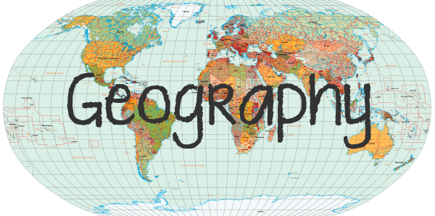

Interconnection

Sustainability
Scale

Environment

Key Stage | Key Concepts Covered
EYFS | Place
KS1 | Place, Space and Environment
LKS2 | Place, Space, Environment, Scale and Change
UKS2 | Place, Space, Environment, Scale, Change, Interconnections and Sustainability
The geographical concepts of place, space, environment, interconnection, scale, sustainability, and change are integral to the development of geographical understanding. They are ideas that can be applied across the subject to identify a question or guide an investigation. They are the key ideas involved in teaching students to think geographically.

Cycle A

Geography Long Term Plan - Cycle A
 | Autumn 1 | Autumn 2 | Spring 1 | Spring 2 | Summer 1 | Summer 2
Year  1/2 |  | Food, Glorious Food  Local field Study Unit  (Rising stars unit-Journey and Food) |  | Down Under and Beyond  Comparison study with Townsville in Australia looking at where food comes from. | Where in the World  (Rising stars unit- People and their communities )
Year  3/4 | The Americas’  Non-European study |  | Rivers and Water Cycle  Local field Study Unit River Yare |  | Earthquakes and Volcanoes  European study
Year 5/6 | Protecting the environment |  |  | Alpine region study  European study | Our World and the Future  Local field Study Unit

Geography Long Term Plan – Cycle B
 | Autumn 1 | Autumn 2 | Spring 1 | Spring 2 | Summer 1 | Summer 2
Year  1/2 | Let’s Explore Lowestoft  Local field Study Unit  (Rising stars unit- Our Local Area) | Out of this World  (Rising stars unit- Seasons) |  |  |  | Our Wonderful World
Year  3/4 | Our World |  | Climate and Weather |  | Coasts  Local field Study Unit east coast/ UK
Year 5/6 | Africa  Local area study  Comparing to a study of a continent |  |  | Changes in our Local Environment  UK/ Local field Study Unit |  | South America – The Amazon  Continent study
Geography Assessment
Pillar | Concept | EYFS | KS1 | LKS2 | UKS2
Develop the pupils as Geographical enquirers | Geographical enquiry |  | Generally, some pertinent geographical questions are asked and answered. | Developing a range of geographical questions are asked and answered accurately. | A good range of good geographical questions are asked and answered.
Develop an understand of local, national and international geography |  |  | Have a growing knowledge of the countries of the United Kingdom and the Countries and oceans of the world.  The 4 countries and capital cities of the United Kingdom are named and there is a growing awareness of many of their characteristics and features.  The world continents and oceans are named accurately and there is some application of this knowledge when describing places. | Know the names of countries and major cities of the United Kingdom are identified and many of the key features of its regions described using geographical vocabulary.  Be able to identify the river's journey from its source to its mouth. | There is a good knowledge of the countries of the United Kingdom, the world’s continents and oceans and a rapidly growing knowledge of other countries around the world.  Have a good awareness of Countries of North and South America and a growing depth of understanding of a particular location.  Have a growing understanding of, and some good descriptions of the significance of geographical features and zones.  Have a growing understanding of various links between geographical regions which are described well.
Develop the use of geographical sources |  |  | Use seasonal and daily weather patterns and generally observe to describe with some detail. They have a growing ability to describe hot and cold areas of the world in relation to the equator, North and South Pole.  Use simple maps that include keys and simple grid references are created in a number of contexts.  Discuss patterns of land use and describe using geographical language. | Has a good level of application of a growing range of terminology to describe geographical patterns.  When reminded of the known ways to describe position and direction, a good range of terminology, reference points including the United Kingdom and the world is used. | Use a number of interesting and pertinent observations about various representations of locations are developed and explored.  There is a growing understanding of some of the key physical and human geographical zones with some good examples given.  With increasing independence and application of terminology, knowledge of the world is well described.  Through investigation, patterns are identified and depicted on maps.
Develop fieldwork skills |  | Enjoys playing with small world reconstructions building on first hand experiences. | A growing use of simple fieldwork skills are used and the key physical and human features of the area surrounding the school and generally described well using some geographical vocabulary.  Use compass directions accurately and use locational language to describe places. | Demonstrate a growing range of fieldwork techniques chosen and applied when investigating the local area.  To develop a range of geographical questions asked and answered accurately.  Geographical vocabulary is generally used to explain reasons for likes and dislikes about locations.  Resources are chosen in order to investigate and describe the characteristics of a place. | Undertake different types of fieldwork that is suggested and used to find specific details of a range of diverse places and to record and present findings in a variety of ways.  Use a growing range of statistics and other information selected and uses to draw some conclusions about locations.  Have a growing awearness that many physical features affect human activity and a variety of good examples are given.
To make comparisons and contrasts |  | To know some similarities and differences between the natural world around them and contrasting environments, drawing on their experiences and what has been read in class | Share some good comparisons using geographical vocabulary used when contracting localities.  Demonstrating a growing repertoire of geographical vocabulary is selected to describe places. | Know a growing number of European countries and their characteristic features identifies comparing and contracting using geographical vocabulary.  Geographical language is selected to describe change to the locality of school over time.  Criteria is chosen from a list to help describe the similarities and differences between Countries.  When reminded of the range of known geographical vocabulary, descriptions include a good level of description. | There is a good awareness of a wide variety of places and features of the world and describe how features have changed over time. Similarities and differences are discussed.  There is a growing understanding of some of the similarities and differences with some good examples provided.  Have a growing awareness of how some locations around the world are changing with some good explanations of the reasons for the changes.  Have a growing understanding of the range of geographical diversities that exist and some good examples are given.
Place |  | Children will explore the natural world around them, making observations and drawing pictures of plants and animals | Children will be able to draw comparisons on their locality to other local places such as where their house, school, local parks, woodland, beach etc. are in relation to each other and will use simple reasoning to give explanation.  Children will understand jobs and what jobs are in the local area.  Children will know simple human and physical features of a locality (beach, forest, hill, shops). | Children will investigate places beyond their locality and have developed a wider knowledge of places in the UK and the World - what are they like, what makes up the place, human and physical features.  Children will know some globally significant human and physical features.  Compare patterns and processes using observations and maps to compare. | Children will understand the global significance of human and physical features.  Children will make detailed comparisons between places and understand why features/ places change.
Space |  | Children will notice detailed features of objects in their environments | Children will have simple locational knowledge.  Children will have knowledge of their locality such as where their house, school, local parks, woodland, beach etc. are and that this makes up their locality.  They will form simple conclusions as to why space is used as it is. | Children will understand what jobs / industries are in our local area and why.  They will understand what forms a community.  Children will investigate transport links and understand how jobs and the economy are affected by these.  Children will understand that what is in the place impacts how we use the space. | Children will have an understanding of the economy and the use of the physical spaces through mapping out the zones of a location.  Children will give detailed reasoning and comparisons about how a place is used, including population.  They will understand the impact of significant things in the news and the effect this has on space.
Environment |  | Children will understand some important processes and changes in the natural world around them, including the seasons and changing states of matter | Children will identify the physical features within the immediate area.  Children will understand the environment needed for farming and food industry.  They will understand what is meant by push and pull factors and what this means to an area.  Children will have a simple understanding of culture. | Children will have a deeper understanding of push and pull to the area and the impact this has.  They will understand how environments change over time.  Children will be able to identify the different parts of the water cycle and understand how they connect.  Children will have a deeper understanding of culture. | Children will investigate erosion and hazards on the environment  .  They will understand the relevance of significant events in the news e.g. lockdown, plastic pollution  Children will partake in reasoning and debating looking at protecting the environment.
Interconnection |  |  | Children will form simple connections between people and places and places and places. For example farm, food and distribution. | Children will develop an understanding of the interconnection between the environmental and human processes and the effect that this can have. | Children will develop an understanding of the impact of environmental and human processes on places and what we can do about them, both positive and negative.
Scale |  | Children will comment and ask questions about aspects of their familiar world such as the place where they live or the natural world | Children will understand their place within their locality. For example house/street/village/town which is part of Suffolk, East Anglia and UK | Children will understand their place within the world. For example country/region/country/continent. | Children will understand how local events have global impact and global events have local impact.
Sustainability |  | Children will understand why we need to show care and concern for living things of the environment | Children will understand what we and other living creatures need to support our lives and what is around us to do this. | Children will gain a simple understanding of sustainability.  They will understand how environments support our and living creatures lives?  Children will gain a simple understanding of human and physical impact on sustainability. | Children will gain an understanding of sustainable and unsustainable ways of life.  They will understand and form an opinion of their role in a sustainable future.  .  Children will know about renewable energy sources and their impact.
Change |  | Children will develop an understanding of growth, decay and changes over time. | Children will understand that a place can change over time.  Children will understand how a place has changed over time.  They will gain a simple understanding of why changes are caused. For example by looking at two maps of different ages; looking at what is different and drawing a simple conclusion. | Children will understand that environmental change can be short or long term and can be impacted by human activity.  Physical, environmental and human changes. | Children will understand that environmental, social, economic and technological change affects places differently.  They will understand how current change can be used to predict the future and identify what would be needed to achieve a preferred and more sustainable future.

Useful Websites and Links

World geography games
https://www.bing.com/search?q=geography+games&qs=n&form=QBRE&sp=1&ghc=1&pq=geography+games&sc=8-15&sk=&cvid=0A3EF40B50F14F0BAB1532721A635CF5

Google Earth
BBC BITESIZE- https://www.bbc.co.uk/bitesize/collections/primary-games/1
National Geographic for kids- https://www.natgeokids.com/uk/teacher-category/geography/
Primary Resources Free- www.primaryresources.co.uk/geography/geography.htm

Interesting reading links

https://www.geography.org.uk/Primary-geography--curriculum-content

https://www.geography.org.uk/write/MediaUploads/Projects/GA_WWILKeyConceptsandBigIdeas.pdf

Visits and possible contact points

UEA geography department- for enquiries to links with school
Contact number- 01603 456161

Carlton marshes
Carlton Marshes,
Burnt Hill Lane,
Carlton Colville
Lowestoft NR33 8HU
Telephone: 01502 564250

Here are 2 experiences offered
Young Geographers
Develop geographical enquiry, vocabulary and skills. Create mini nature reserves using mapping techniques. Use orienteering and compass skills to complete the photo trail. Investigate landscapes and landscape change, looking at the past and present and making predications for the future.
Eco-action
A day designed to empower and inspire young people to take action for environmental sustainability. Investigate our impact on the planet and look at options for alternative energy, water usage and food miles. Design a boat powered by wind or solar power, play the water conservation game and work out the food miles of a bag of shopping.

